

GreenGame
Students’ Handbook

The Adventures of an Ecological Hero

Contents

1. Introduction 3
2. Teacher´s Handbook Purpose 7
3. Education Goals and Learning Outcomes 8
4. Organising events to showcase the games created 14
5. Instructions for electronic Green Game 15
6. Progression and Rewards in Environmental Conservation 25
7. Troubleshooting in Essential Environmental Topics 26
8. Student Feedback Questionnaire 29
9. Additional Green Games 30

Introduction
Welcome to the Green Game for an interactive game designed to support children in developing pro-environmental behaviours and a sustainable lifestyle. This handbook has been created by the Green Game project to provide you with all the information you need to get the most out of this unique and exciting game.
Climate change and environmental degradation are seen as a big threat in Europe. While government policies and actions aim to raise awareness about sustainable development and promote healthy lifestyles, just raising awareness is not enough. Even though Europeans acknowledge the seriousness of climate change, they don’t always take action to change their habits. This can negatively impact children, whose environmental attitudes form at a young age.
GreenGame project aims to support children (10-14 years old) to engage in pro–environmental behaviours and to achieve an environmentally friendly way of living, by establishing an enhanced degree of motivation, willingness, autonomy and commitment and to assist teachers in stimulating pro-environmental behaviour to their students.
The GreenGame pro-environmental behaviour innovative game includes empowerment and motivation enhancing interventions for habit formation and change, focusing on linking individual behaviour change with overall social benefit.
We suggest using the game jointly with the GreenGame Psycho-education program on development of pro-environmental behaviour based on mindfulness and awareness raising interventions, material and activities.
The publication has been produced within the Erasmus+ Strategic Partnership in school education “GreenGame - Pro-environmental behavior development for school-age children” (2022-2024) financed by the European Union.
The partnership includes: Creative Ideas (Latvia), INSTITOUTO EREFNAS KAI THERAPIAS TIS SIMPERIFORAS (Greece), UNIAO DAS FREGUESIAS DE GONDOMAR (SCOSME) VALBOM E JOVIM (Portugal), Akademia Humanistyczno-Ekonomiczna w Lodzi (Poland), DEP INSTITUT (Spain) un Arsakeio Gymnasium Patras (Greece).
Project website: greengamepro.eu

Environmental education (EE) is a process that helps individuals, communities, and organizations learn more about the environment, and develop skills and understanding about how to address global challenges. It has the power to transform lives and society. It informs and inspires. It influences attitudes. It motivates action.
The importance of environmental education at schools cannot be overstated. EE can benefit students, teachers, schools, and communities in many ways. Here are some of the reasons why EE should be integrated into the school curriculum:
EE improves academic achievement. Using outdoor settings like the schoolyard, nearby parks, or public lands can infuse a sense of richness and relevance into a traditional school curriculum. Students who participate in EE often experience advances in core academic areas such as science, math, language arts, and history.
EE enhances critical and creative thinking skills. EE encourages students to research, investigate how and why things happen, and make their own decisions about complex environmental issues. By developing and enhancing critical and creative thinking skills, EE helps foster a new generation of informed consumers, workers, as well as policy or decision makers.
EE supports tolerance and understanding. EE encourages students to investigate varying sides of issues to understand the full picture. It promotes tolerance of different points of view and different cultures.
EE encourages healthy living. EE teaches students about the interdependence of humans and nature, and the importance of maintaining a healthy environment for the well-being of both. EE also promotes physical activity and outdoor recreation, which can improve mental and physical health.
EE strengthens communities. EE fosters a sense of environmental stewardship and civic responsibility among students, teachers, and parents. EE also provides opportunities for collaboration and partnerships among schools, local organizations, and community members.
As you can see, environmental education is not only beneficial for the environment, but also for the education system and society as a whole. By incorporating EE into the school curriculum, we can prepare our students for the future challenges and opportunities they will face in a changing world.
Games are a great way to learn about environmental matters, as they can make complex topics more engaging, interactive, and fun. Games can also help students develop skills such as problem-solving, critical thinking, collaboration, and creativity. Here are some examples of how students can learn about environmental matters from games:
NOAA Games is a collection of games and activities from the National Oceanic and Atmospheric Administration (NOAA) that teach students about topics such as weather, climate, oceans, coasts, and marine life. Students can learn about the causes and effects of natural disasters, the role of the ocean in regulating the climate, the diversity of marine ecosystems, and more.
Clim’Way is a game that challenges students to reduce greenhouse gas emissions and adapt to climate change in a virtual city. Students can choose from various actions and policies that affect different sectors such as energy, transportation, agriculture, and industry. Students can see the impacts of their choices on the environment, the economy, and the society.
Windfall is a game that simulates the management of a wind farm. Students can learn about the benefits and challenges of renewable energy sources, such as wind power. Students can design their own wind turbines, choose where to place them, and monitor their performance and profitability.
Play Oil God is a game that explores the geopolitics of oil production and consumption. Students can play as an oil tycoon who controls the oil supply of different regions. Students can manipulate the oil prices, start wars, cause natural disasters, and influence the global politics. Students can learn about the environmental and social consequences of oil dependence and the need for alternative energy sources.
Recycle City is a game that shows how people can reduce waste, use less energy, and save money by doing simple things at home, at work, and in their neighborhoods. Students can explore Recycle City and discover how its residents recycle, reuse, and compost materials. Students can also play the Dumptown Game, where they can improve a city’s environment by implementing recycling programs and other initiatives.
Lifeboat to Mars is a game that teaches students about ecology and evolution. Students can create their own ecosystems on a virtual Mars and populate them with different organisms. Students can learn about the interactions between living things and their environment, the adaptations of organisms to different conditions, and the processes of natural selection and speciation.
Smog City 2 is a game that demonstrates how air pollution is affected by various factors such as weather, population, industry, and transportation. Students can adjust these factors and see how they change the air quality index (AQI) and the health effects of smog. Students can learn about the sources and types of air pollutants, the ways to prevent and reduce air pollution, and the importance of clean air for human health.
Mission Migration is a game that lets students experience the challenges faced by migratory birds. Students can guide a flock of birds across different landscapes and seasons. Students can learn about the factors that influence bird migration, such as food availability, predators, habitat loss, climate change, and human activities.
These are just some of the many environmental games that students can play to learn about environmental matters. Games can be a powerful tool for environmental education, as they can spark curiosity, raise awareness, and inspire action among students.

The European Commission’s support for the production of this publication does not constitute an endorsement of the contents, which exclusively reflect the views of the authors, and the Commission cannot be held responsible for any use which may be made of the information contained therein.

The publication is licensed under a Creative Commons Attribution 4.0 International License.

Teacher´s Handbook Purpose
Objectives
To help students understand the role of ecological heroes in preserving the environment.
To become familiar with the educational manual of an online game that promotes ecological awareness.
Prior knowledge required
Understanding of the basic principles of ecology.
Knowledge of the basic characteristics of computer games.
Stimulant ensemble
Presentation of the game 'The Ecological Hero'.
Explanation of the main elements of the educational manual.
Discussion on the importance of ecological challenges in modern society.
Direct Teaching Strategies
Multimedia presentation on the game 'The Ecological Hero'.
Demonstration of the educational manual through an interactive platform.
Discussion on the challenges faced by the ecological hero in the game.
Support tasks
Analysis of the main themes of the game.
Developing strategies to solve the ecological problems presented in the game.
Develop initiatives to promote ecological awareness in the community.
Group work activities
Form teams to develop games with an ecological theme.
Organising events to promote the games created.
Discuss the impact of the games created on the ecological awareness of the players.
Evaluation measures
Questions analysing the main themes of the game.
Presentation of the strategy followed by the team to solve the ecological problems.
Analysis of the impact of the games created on the ecological awareness of the players.
Deep questions
What is the role of ecological games in today's society?
How can we apply the ecological values acquired from games to real life?
What is the role of the eco-hero in promoting ecological awareness?

Education Goals and Learning Outcomes
Objectives
- Understand the concept of education goals and learning outcomes.
- Analyze the impact of education goals on personal and societal development.
- Evaluate the effectiveness of learning outcomes in an ecological context.
Prior Knowledge
- Knowledge of ecological concepts and the role of environmental sustainability in education.
Cue Sets
- Introduce the concept of education goals through a scenario involving an ecological hero.
- Discuss the interplay between education goals and learning outcomes.
- Engage in a debate about the importance of incorporating ecological awareness into educational objectives.
Direct Instruction Strategies
- Lecture with multimedia presentation on the significance of education goals in shaping ecological awareness.
- Small-group discussions on the connection between education goals and personal development.
- Role-play activity demonstrating the implementation of education goals within an ecological framework.
Practice Assignments
- Complete a reflective writing assignment on the impact of education goals on personal values.
- Create a visual representation illustrating the relationship between education goals and ecological sustainability.
- Analyze case studies to identify successful implementation of education goals in ecological initiatives.
Team-Based Activities
- Collaborative research project exploring education goals in various ecological hero narratives.
- Design and present a proposal for integrating ecological education goals into the school curriculum.
- Engage in a simulation game to apply education goals and learning outcomes in an ecological context.
Formative Assessment Measures
- Peer evaluation of reflective writing assignments.
- Group presentation rubric assessing the integration of ecological hero narratives with educational objectives.
- Observational checklist during role-play activity to gauge understanding of education goals and learning outcomes.
Deep Questions
- How do education goals shape our understanding of ecological responsibility?
- What role do learn outcomes play in promoting ecological awareness?
- How can education goals be tailored to address ecological challenges in the modern world?

STUDENTS´ EDUCATIONAL GOALS | TEACHERS´ LEARNING OUTCOMES
Content Knowledge
a. Acquisition of knowledge about key environmental concepts.  b. Deepen and apply the understanding of environmental issues. | a. Help your students develop a better understanding of various environmental concepts and sustainable practices, such as mobility and pollution, green consumption in general and green eating in particular, renewable energies, saving water and electricity, reusing and recycling.  b. Transfer knowledge (active and deep learning) - optimal education experience.
Critical Thinking Skills
a. Development of critical thinking skills.  b. Analysis of information, option´s evaluation, informed decision-making, and weighing the consequences of one's choices. | a. Present students with environmental challenges and dilemmas within the subjects.  b. Help them with analysis, problem-solving, and decision-making, needed for those challenges and dilemmas.
Problem-Solving Abilities
a. Enhance students' problem-solving abilities.  b. Identify problems, brainstorm potential solutions, and implement strategies. | a. Engage students in the game's environmental scenarios.  b. Understand the benefits of game-based learning, a teaching-learning method that will encourage them to identify problems, brainstorm solutions, and implement strategies to address environmental issues effectively.
Awareness and Empathy
a. Awareness of environmental problems.  b. Foster empathy for the natural world.  c. Appreciation of the value of nature. | a. Raise awareness, through gameplay and storytelling, about environmental problems and inspire empathy for the natural world.  b. Teach them about the interdependence between humans and nature, realizing the impact their actions have on the environment and other species and broaden the understanding of the interconnectedness of ecosystems and human activities.  c. Help the students develop a sense of responsibility and stewardship.
Collaboration and Communication
a. Collaboration among peers, family and community.  b. Development of communication skills. | a. Promote collaboration and develop communication skills among players.  b. Emphasize the importance of teamwork, cooperation, sharing ideas, and considering diverse perspectives to address environmental challenges collectively.  c. Share experiences, discuss strategies within a network of colleagues, researchers, and experts in the field of environmental education that learn from each other and strengthen the collective knowledge base.  d. Promote a supportive professional community focused on environmental education and contribute to the development of best practices in game-based environmental education.
Action and Behaviour Change
a. Action in their own lives and within their communities.  b. Adoption of sustainable behaviours.  c. Advocate for positive change. | a. Motivate students to take real-life actions to protect the environment and advocate for green change.  b. Foster and encourage sustainable behavioural changes and habits: encourage students to apply what they've learned to their daily lives.
Technology Skills
a. Apply technology skills in using meaningful educational technology tools to then usefully apply that learning on daily lives. | a. Be aware of the successful use of digital serious games as a learning resource.  b. Become competent in using educational technology tools.  c. Utilize and incorporate technology into teaching practices (technology integration).  d. Develop skills in navigating educational technology platforms, managing virtual environments, and effectively utilizing game-based learning.  e. Be empowered to harness the potential of technology for impactful environmental education.
Cross-Curricular Connections
a. Acquire overall knowledge trough interdisciplinary learning. | a. Identify opportunities to connect the game's content and issues with different disciplines (integrate the game into existing curricula).  b. Facilitate the integration of the game into various subjects and curricula, promoting interdisciplinary learning and reinforcing learning across different disciplines.
Reflection and Self-assessment  a. Reflection about individual and shared experience and knowledge. | Reflection and Self-assessment  a. Use the serious game as a starting/ending point to discuss environmental issues.  b. Encourage students to reflect on their gaming experience.  c. Provide opportunities for self-assessment, discussion, insight sharing, and reflection on the knowledge gained, skills developed, and personal growth achieved through the game.  d. Promote critical thinking and reflection on environmental issues.  e. Critically examine one´s own approach to environmental education and identify areas for improvement.  f. Reflect on ones´ environmental attitudes, behaviours, and teaching practices.  g. Explore alternative assessment strategies for evaluating by analysing students decision-making processes as indicators of their understanding and application of environmental concepts.
Real-World Application
a. Application of knowledge and skills to the real-world.  b. Engage in practical projects and community actions. | a. Maximize the knowledge transfer so that information acquired can be re-used at a later stage by the students.  b. Encourage the students to engage in practical projects or community actions that contribute to environmental sustainability.  c. Enable students to apply the knowledge and skills acquired from the game to real-world environmental issues.

The GreenGame is an exciting online gaming experience that combines conscientiousness, environmental awareness and interactive challenges. Players start a two-week journey and they become the heroes of their own story, navigate different environmental spheres and adopt sustainable practices in their daily lives.
Guided by a set of daily goals, students journey through seven key thematic areas, including recycling, water conservation, energy conservation and eco-friendly transportation. By completing these tasks, players earn valuable points that contribute to their progress. Each successful completion brings them closer to their ultimate mission: to protect the environment and make a positive impact on the world. Within this immersive environment, players interact with specially designed characters, explore vibrant backgrounds, and participate in a variety of challenges tailored to promote sustainable behaviors.
Players can communicate and collaborate with their peers, sharing experiences and knowledge about critical issues at hand. Through this shared learning experience, they not only build a deeper understanding of sustainability, but also foster a sense of community and collective responsibility.
With a different approach to education and play, GreenGame stands out as a proactive initiative, offering a unique blend of entertainment and environmental awareness. By empowering the younger generation with knowledge and practical tools for sustainability, the game aims to create a transformative impact, cultivating a generation of conscious, ecologically aware individuals committed to shaping a greener, more sustainable future.

Organising events to showcase the games created

Discussion on the impact of the games created on the ecological awareness of the players.

Evaluation measures

Questions analysing the main themes of the game.

Presentation of the strategy followed by the team to solve the ecological problems.

Analysis of the impact of the games created on the ecological awareness of the players.

Deep questions

What is the role of ecological games in today's society,

How can we apply the ecological values acquired from games to real life,

What is the role of eco-hero in promoting ecological awareness, mote sustainable behaviours.

Instructions for electronic Green Game

Let’s play day by day.

Open the game and complete the daily task.
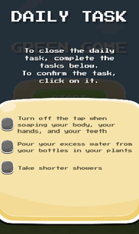

Click on the Setting button to choose our language, then click on the Start button.

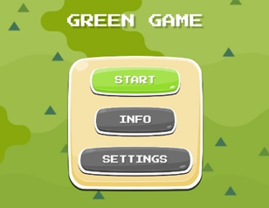

By pressing the Start button, we have access to the different levels in the window below:
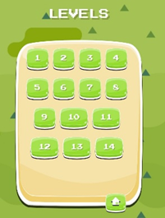

Whenever you want to go back to the previous menu, you can do it using the button shown below. This button is available at all times during the game (before the instructions, in the level window and during the game).
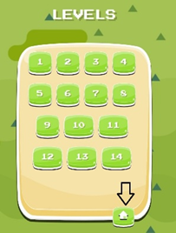

By clicking on a level, we have access to the instructions for the task to be performed.
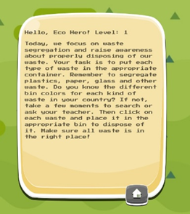

Once the task has been checked, we can start the game by clicking on the Start button.
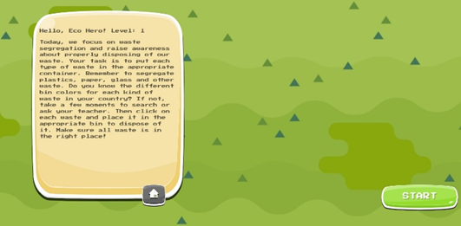

DAY 1
Today, we are focusing on waste separation and raising awareness about proper disposal of our waste. Your goal is to place each type of waste in the appropriate container. Do you know the different colours of bins for each type of waste? If not, take a few minutes to research it or ask your teacher. Click on each waste and place it in the appropriate bin. Make sure all the waste is in the right place!
We all need to be aware of the amount of waste we produce and its impact on the planet. If we dispose of our waste correctly and recycle it, then its impact can be reduced.
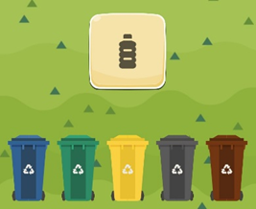

DAY 2
The tree planting mission is waiting for you today! Did you know that trees have countless benefits for everything on the planet, from marine animals to the countless people working around the world? If not, take a few minutes to research or ask your teacher. Drag a small tree to the spot marked on the board and plant it.
Planting trees brings life to your area, improves the quality of life and helps fight climate change. It's good for you and for the planet.

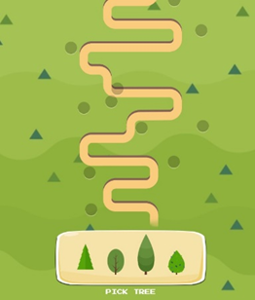

DAY 3
Look around you - how many plastic bottles and other single-use items do you see around you every day? Today we want to raise awareness about the use of reusable items such as bottles and other materials. Your job is to talk to other students and get them to start using reusable bottles instead of single-use plastic bottles. Click on students to start a conversation and then answer their questions. Show that caring for the environment can be simple and beneficial for all of us!
We all need to think before we buy or acquire a new item: "Do I really need this?" How could I reuse something I already have?

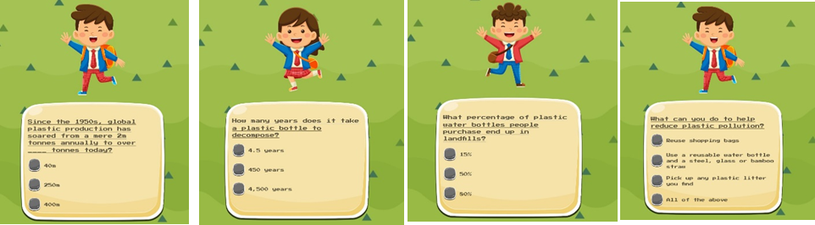

DAY 4
Today we will go to the nearby forest where rare trees grow. Your task is to protect this natural area from over-tourism. Click tourists to inform them about the importance of nature conservation. Show us how we can help preserve natural treasures!
Always remain environmentally friendly when traveling. By travelling responsibly and respecting the environment and ecosystem you can make a difference. It's good for you and the planet.
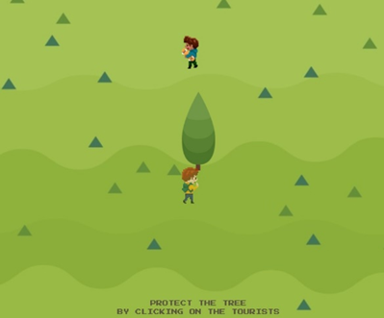

DAY 5
The food we eat gives our bodies energy to move, run, dance and think! Did you know that some foods are good for us and our planet and others not so much? Today, your task is to choose which food is healthy for you and which is not from 10 different options.
We all need to think about our food choices and their impact on our health and the environment. Prepare your lunch box so that it contains more healthy than unhealthy options for you. It's good for you and the planet.

.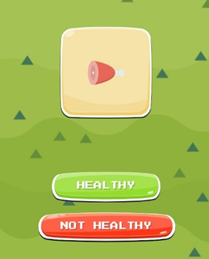

DAY 6
Did you know that water takes up 70% of the Earth's surface, but only 1% of water is usable? Today we focus on cleaning up a polluted stream. Your job is to find the source of the pollution and remove it. Click on the trash in the stream and drag it to the appropriate bin to clean the stream. Show how important it is to take care of our water and protect aquatic ecosystems!
Clean water is vital for nature, our health and quality of life. Therefore, we must keep our water clean and use it wisely and responsibly.
.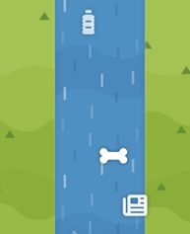

DAY 7
Using sustainable and ecological means of transport makes our lives better. Different means of transport are more or less ecological. Nowadays, you come across a group of people who often use cars, causing a lot of air pollution. Your goal is to convince them to use more ecological means of transport, such as public transport or cycling.
Clean air is vital for nature, health and our quality of life. Therefore, we should take care of the purity of our air and use the Earth's natural resources wisely and responsibly.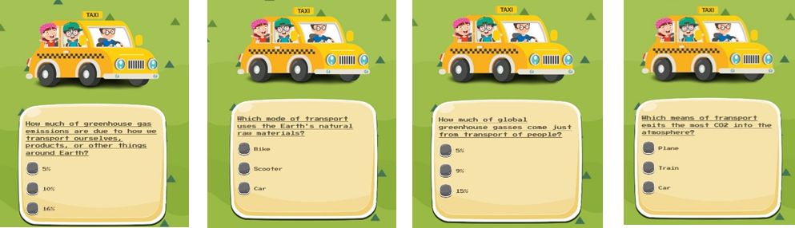

DAY 8
Today, we focus on paper waste. Why is it important? Because paper waste is a huge problem, causing deforestation. What can you do to help reduce paper waste?
Reducing paper waste protects forests and that makes our planet greener and cleaner for you and future generations!
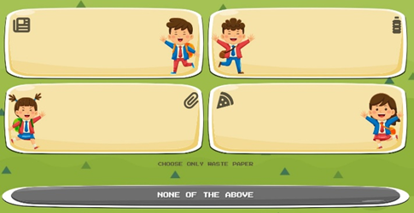

DAY 9
Today, we focus on protecting a local natural area from developers. Your task is to organise a social campaign, collect signatures and educate residents about the values of the area. Click on passers-by to collect their signatures to protect the area. Show how important it is to preserve our natural heritage!
Natural areas provide clean air and water, healthy soils and space for plants and animals. By preserving natural areas we create a better life for ourselves and future generations.
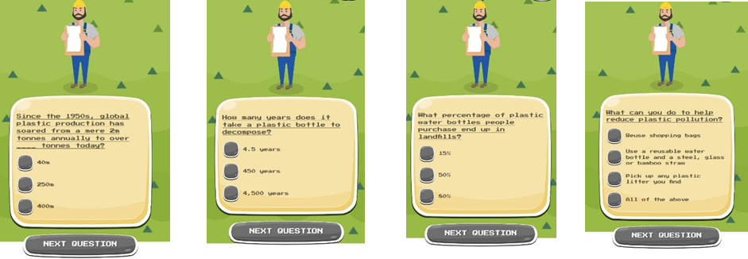

DAY 10
Non-ecological means of transport leave a large carbon footprint. They emit huge amounts of CO2 into the atmosphere and consume many of the Earth's natural resources. Energy production also creates a lot of waste. Today, you are visiting a local factory that uses a lot of energy. Your goal is to develop an energy-saving plan and convince the factory management to implement the changes.
A clean Earth is vital to our lives and health. It makes our lives better and longer. Therefore, we must take care of the Earth's purity and use its natural resources responsibly.
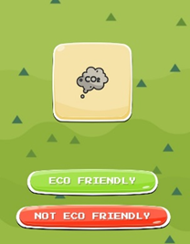

DAY 11
Today we will meet with a local TV station where you will be interviewed about your environmental activities. Your job is to showcase your achievements and convey the message of caring for the planet. Click on the relevant parts of the text during the interview to answer the questions correctly. Show how we can inspire others to change their behaviour!
We appreciate your active work to promote eco-friendly lifestyles in your community. It's good for you and for the planet.
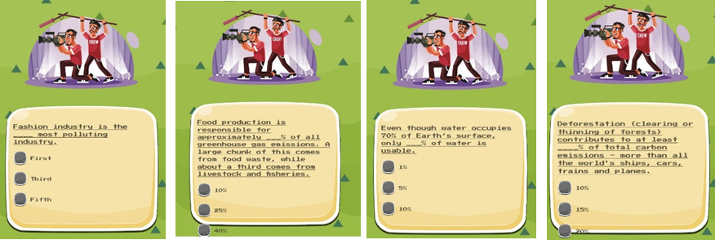

DAY 12
In our daily lives there are many messages around us. Answer the question below about ecological messages.
Every day we can all rest the Earth and encourage those around us to do the same.
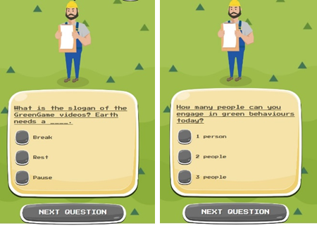

DAY 13
Today you will create green spaces in your city! Did you know that planting trees helps improve air quality, reduce noise and cool our cities? Show how important it is to maintain a balance between the city and nature. Your task is to gather a group of volunteers and identify suitable places to plant new trees. Drag the icons on the board to plant them in the designated places.
Parks and green spaces make cities a better place to live. They improve air quality and reduce noise pollution, create space to exercise, relax and meet other people. By creating and maintaining green spaces in cities we create more sustainable and equitable communities for all.
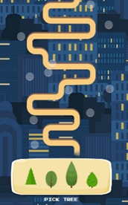

DAY 14
Now it's time to put your green knowledge to the test on this last day of the game. Answer the questions below about various ecological issues.
Excellent! Thank you for contributing and becoming an eco-hero. Remember to apply your green knowledge to your daily activities.
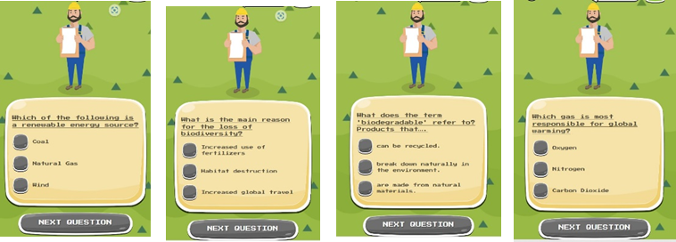

At the end of each level there's always a good job window.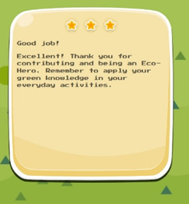
Regarding the qualification, you will have 1, 2 or 3 stars at the top of the good job window.

Progression and Rewards in Environmental Conservation

Objectives
- Students will be able to analyze the progression and rewards of environmental conservation efforts.
- Students will be able to evaluate the impact of recycling, water conservation, energy-saving, and eco-friendly commuting on the environment and society.
- Students will be able to propose actionable strategies for promoting environmental conservation in their community.

Requisite Prior Knowledge
- Understanding of the basic concepts of environmental conservation.
- Familiarity with the principles of recycling, water conservation, energy-saving, and eco-friendly commuting.

Cue Sets
- Brainstorming session on the potential rewards of environmental conservation efforts.
- Group discussion on the progression of environmental conservation initiatives in the local community.
- Analysis of case studies showcasing successful eco-friendly practices.

Direct Instruction Strategies
- Lecture: Introduction to the concept of progression and rewards in environmental conservation.
- Visual Aids: Presentation of data and visuals depicting the impact of recycling, water conservation, energy-saving, and eco-friendly commuting.
- Real-Life Examples: Sharing of success stories and best practices in environmental conservation efforts.

Practice Assignments
- Case Study Analysis: Investigate and analyze a real-world example of successful environmental conservation initiatives.
- Role-Playing: Simulate scenarios that demonstrate the impact of individual actions on environmental progression and rewards.
- Debate: Engage in a structured debate on the effectiveness of different environmental conservation methods.

Team-Based Activities
- Community Outreach Plan: Collaborate to devise a plan for promoting environmental conservation in the local community.
- Design Challenge: Work in teams to create a visual representation of the benefits of eco-friendly practices.
- Interactive Workshops: Organize and conduct workshops on recycling, water conservation, energy-saving, and eco-friendly commuting for peers.

Formative Assessment Measures
- Peer Evaluation: Assess and provide feedback on each other's case study analyses.
- Group Presentation: Evaluate group presentations on the proposed community outreach plans.
- Quiz: Administer a short quiz to gauge understanding of the concepts covered.

Deep Questions
- How can individual actions contribute to the progression of environmental conservation efforts?
- What are the potential rewards, both personal and societal, of engaging in eco-friendly practices?
- How can we inspire and motivate others to participate in environmental conservation initiatives?
This game is designed to engage students in critical thinking and practical application of environmental conservation concepts, focusing on the progression and rewards of efforts related to recycling, water conservation, energy-saving, and eco-friendly commuting.

Troubleshooting in Essential Environmental Topics

Unit Overview
The Troubleshooting in Essential Environmental Topics unit plan is designed for upperclass students (Grade 11-12) to develop a deeper understanding of critical environmental issues such as recycling, water conservation, energy-saving, and eco-friendly commuting. The unit will address the identification and resolution of problems related to these topics, encouraging students to develop practical solutions and critical thinking skills.

Unit Objectives
1. Recycling
  - Understand the importance of recycling in reducing waste and conserving resources
  - Identify common recycling challenges and propose innovative solutions
2. Water Conservation
  - Recognize the significance of water conservation for sustainable living
  - Analyze water usage patterns and propose strategies for conservation
3. Energy-Saving
  - Comprehend the impact of energy consumption on the environment
  - Identify energy-saving opportunities and develop action plans to reduce energy usage
4. Eco-Friendly Commuting
  - Explore alternative transportation methods for reducing carbon emissions
  - Evaluate the benefits of eco-friendly commuting and propose ways to promote it in the community

Lesson 1: Introduction to Environmental Troubleshooting
Objective: Introduce students to the concept of environmental troubleshooting and its relevance to sustainable living.
Activities:
- Group discussion on current environmental challenges
- Case studies on successful troubleshooting in environmental issues
- Brainstorming session on potential problems in recycling, water conservation, energy-saving, and eco-friendly commuting
Assessment:
- Written reflections on the significance of environmental troubleshooting

Lesson 2: Understanding Recycling Challenges
Objective: Examine common challenges in the recycling process and brainstorm innovative solutions.
Activities:
- Analysis of recycling infrastructure in the local community
- Guest speaker session from a recycling expert
- Group activity to identify and propose solutions for recycling challenges
Assessment:
- Presentation of proposed solutions for recycling challenges

Lesson 3: Water Conservation Strategies
Objective: Explore the importance of water conservation and develop practical strategies to reduce water usage.
Activities:
- Water usage audit at home or school
- Research on innovative water conservation techniques
- Creation of a water conservation action plan
Assessment:
- Submission of water conservation action plan with measurable goals

Lesson 4: Energy-Saving Initiatives
Objective: Investigate energy consumption patterns and devise plans to minimize energy usage.
Activities:
- Energy audit of personal living spaces
- Discussion on renewable energy sources
- Collaborative development of an energy-saving action plan
Assessment:
- Peer review of energy-saving action plans

Lesson 5: Promoting Eco-Friendly Commuting
Objective: Analyze the environmental impact of commuting and propose sustainable transportation alternatives.
Activities:
- Comparative analysis of different transportation modes
- Group project on promoting eco-friendly commuting in the community
- Presentation of eco-friendly commuting proposals
Assessment:
- Evaluation of eco-friendly commuting proposals based on feasibility and environmental impact

Culminating Activity: Troubleshooting Project
Objective: Apply troubleshooting skills to address real-world environmental challenges.
Activities:
- Identification of an environmental issue in the community
- Development of a comprehensive troubleshooting plan
- Presentation of troubleshooting project findings and proposed solutions
Assessment:
- Rubric-based assessment of troubleshooting project presentations

Conclusion
The Troubleshooting in Essential Environmental Topics unit plan aims to equip upperclass students with the knowledge and skills to identify, analyze, and resolve critical environmental issues. By fostering critical thinking and problem-solving abilities, students will be empowered to contribute to a more sustainable and eco-conscious society.

Student Feedback Questionnaire

You have now completed your journey as an eco-hero! It’s time to let us know what you thought of this journey…
(This question is mandatory)
1. Was the game easy to play?
- 😀 A. Yes, it was easy to play
- 😐 B. More or less
- 🙁 C. I struggled
(This question is mandatory)
2. Did you at any point need help from a teacher to navigate the game? (to start the game, moving through the game, etc.)
- 😃 A. I managed on my own
- 😐 B. A little help
- 🙁 C. I needed a lot of help
(This question is mandatory)
3. The activities in the game were fun
- 😃 A. Yes, definitely
- 😐 B. Somewhat
- 🙁 C. No, not really
(This question is mandatory)
4. Through the games I learned more about caring for the environment
- 😃 A. Yes, a lot
- 😐 B. A little bit
- 🙁 C. I didn't learn much
(This question is mandatory)
5. I would recommend the game to other students
- 😃 A. Yes, definitely
- 😐 B. Maybe
- 🙁 C. No I wouldn't
6. What did you like best about the Green Game?
Finally, can you tell us a little bit about you:
(This question is mandatory)
7. I am a:
- girl
- boy
- prefer not to answer
(This question is mandatory)
8. I am
years old
9. I am from:
Choose one of the following answers
Please choose... France Greece Latvia Poland Spain

Additional Green Games

- Find the country from the flag!


Solution:
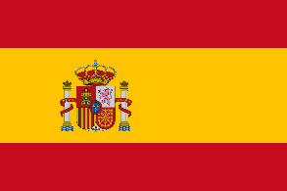
Solution:
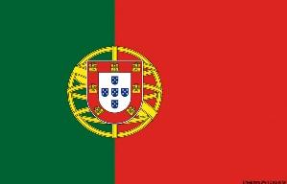
Solution:

Solution:

Solution:

- Below, match the parks that are in each country.

1 Oceanário de Lisboa
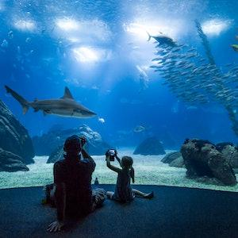

2 Lazienki park
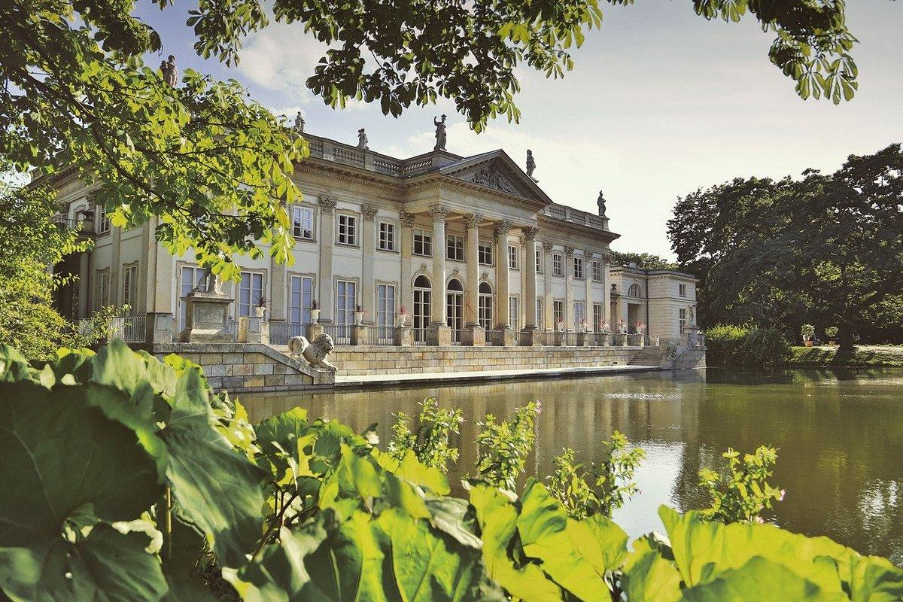

3 Parc de la Barceloneta
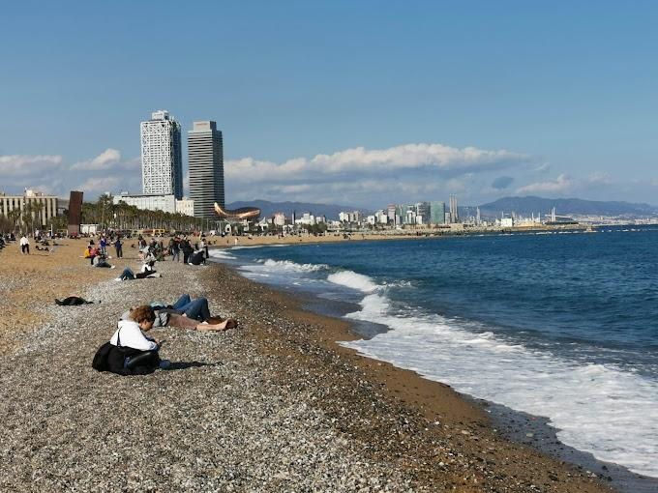

4 Olympus


Ι)  ΙΙ)  ΙΙΙ)  ΙV) 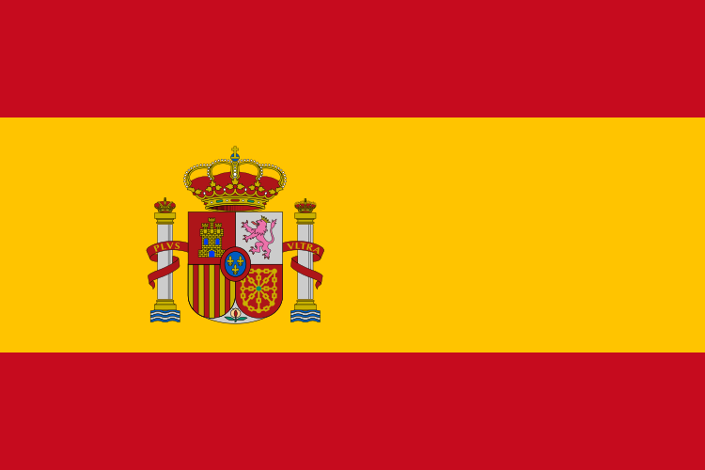

- Match the mountains with the correct country

- Pico Ruivo
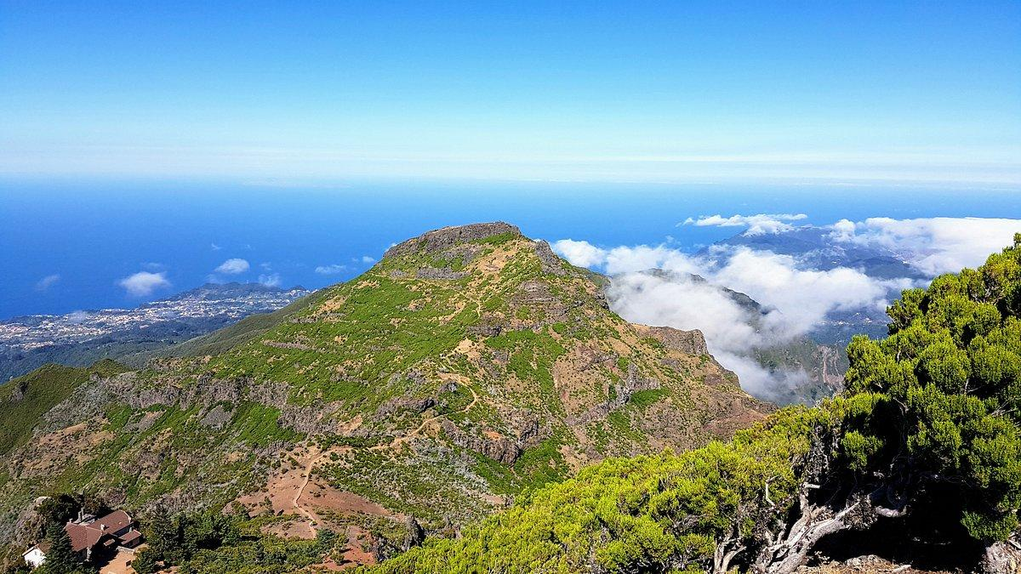

- Peña de los Enamorados
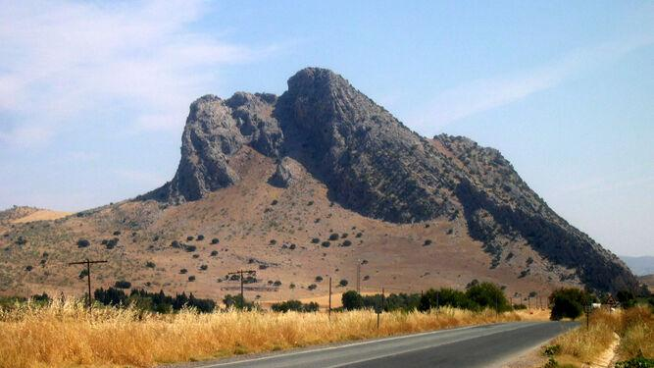

- Olympus
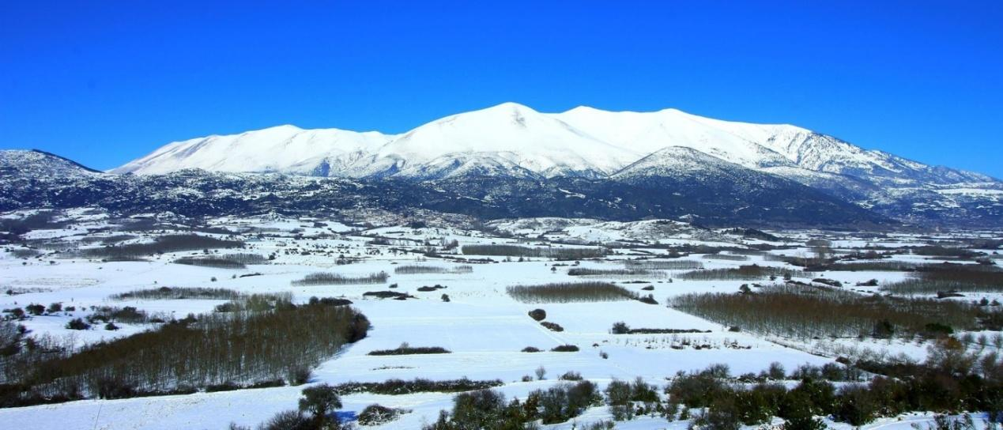

- Tarta Mountains


Ι) ΙΙ) ΙΙΙ) ΙV) V)

- Match the beaches or the islands with the correct country

- Lagos
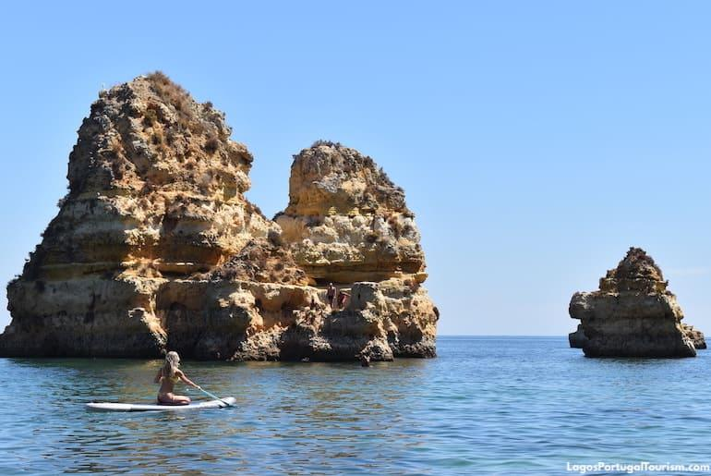

- Tenerife
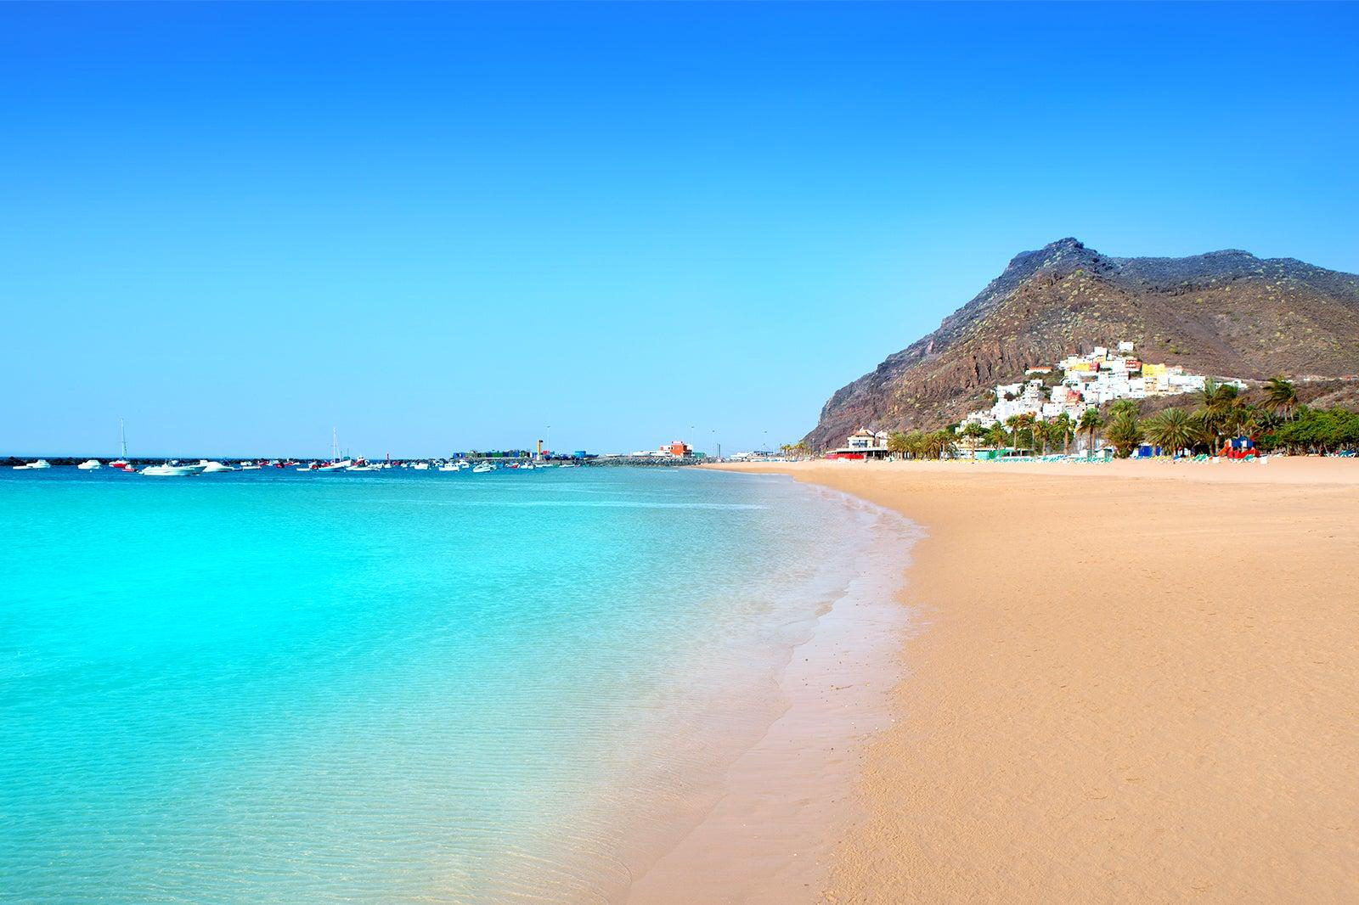

- Corfu
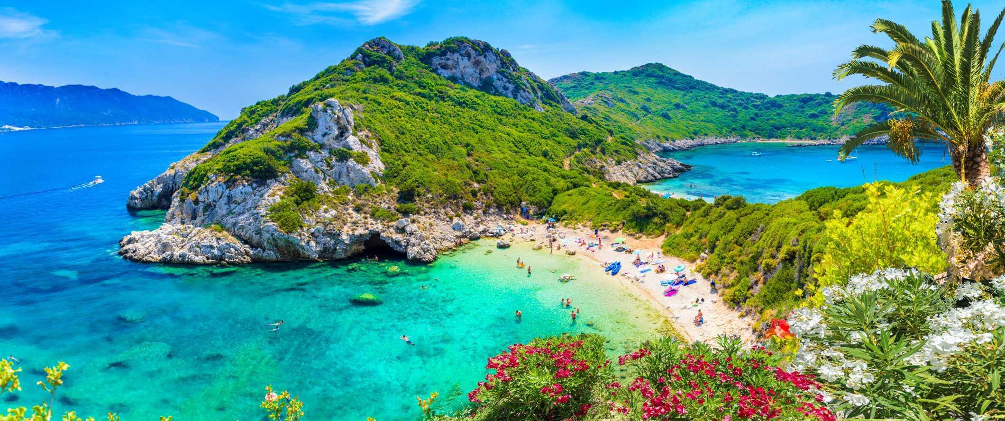

- Sopot beach 5) Jurmala beach
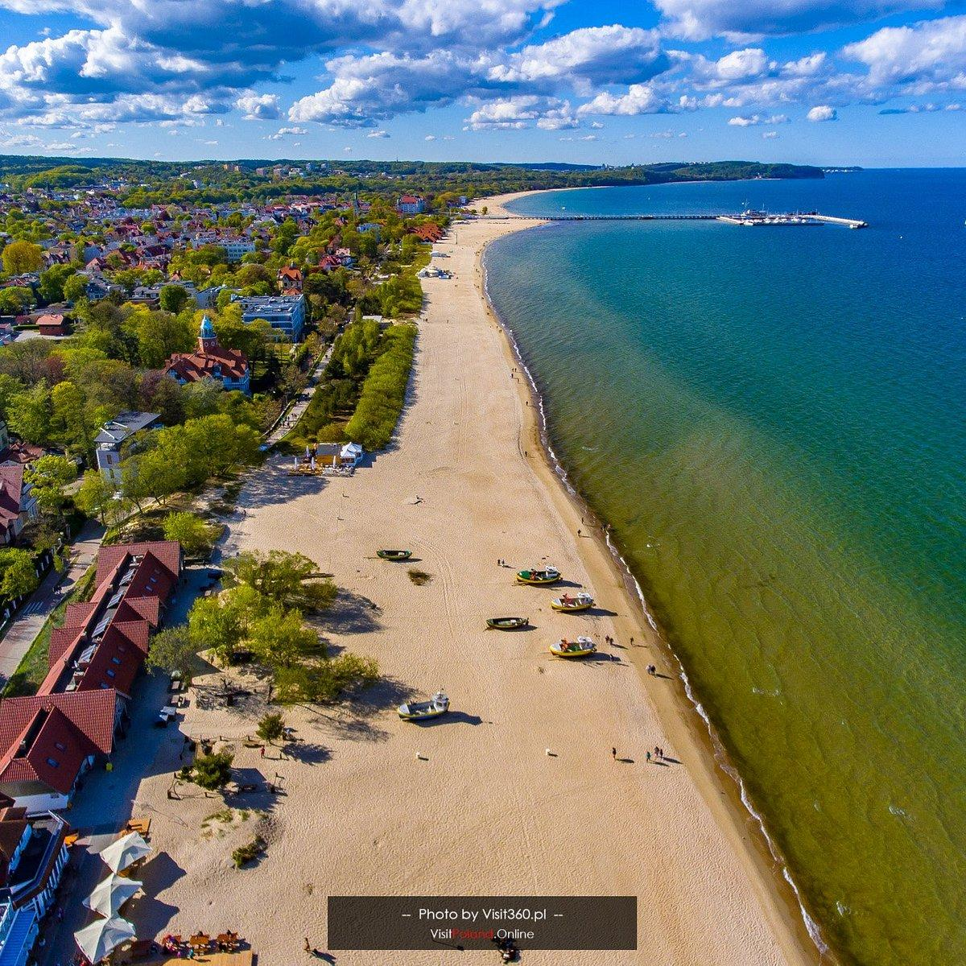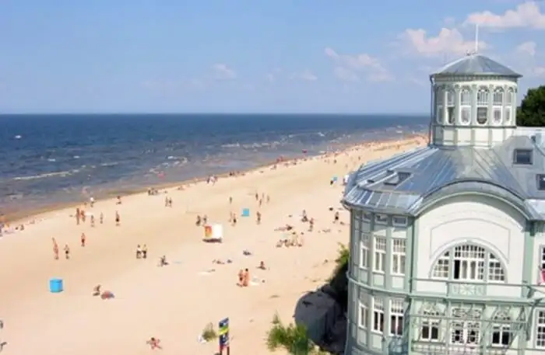

Ι) ΙΙ) ΙΙΙ) ΙV)

- Match the places to the corresponding photo!

1.
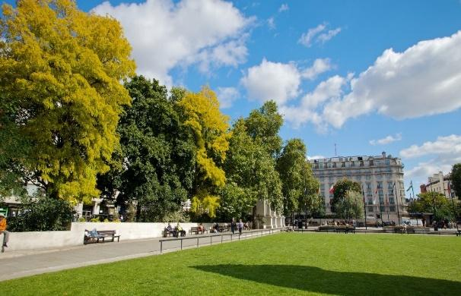
2.
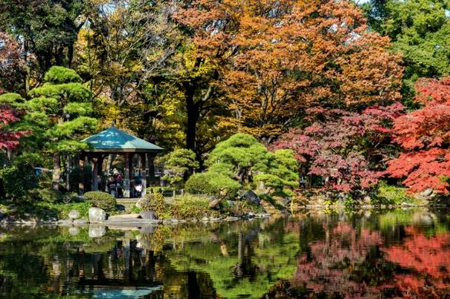
3.
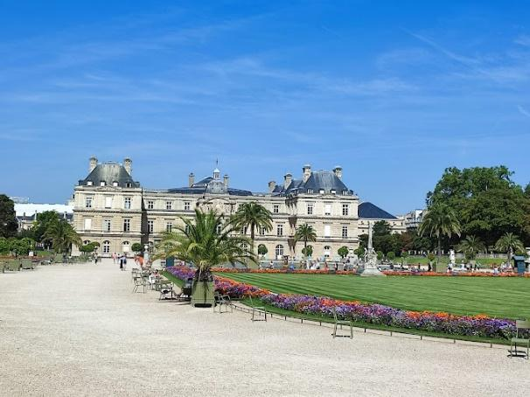
4.
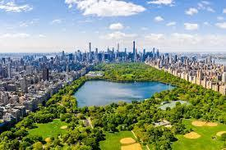

5.
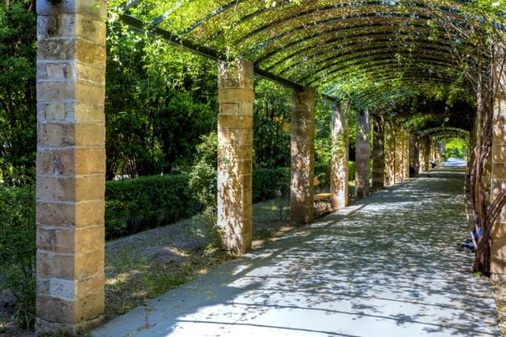
6.
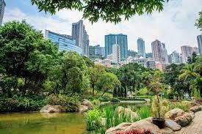

1 | 2 | 3

4 | 5 | 6

  - National Gardens – Athens
  - Central Park – New York
  - Hong Kong Park – Hong Kong
  - Hyde Park - London
  - Luxemburg Gardens – Paris
  - Hibiya Park - Tokyo

- Choose the correct answer

What should you do when you are washing the dishes?
- Keep the tap on, so it is easier to rinse
- Turn off the tap when you aren’t using it
- Always fill up the dishwasher
- Both b and c

How can you save water while watering your plants?
- keep the sprinklers on all night
- use a hose
- use a watering can
- none of the above

How can you use less water in the shower?
- Have a shower instead of a bath
- Shower for less time
- Only use the water when you need it
- All of the above

- Match

Save rain water
Turn off water
Collect baths
Don’t take the dishwasher
Use the tap

- A Game for Big Brains

This is one of the hardest challenges! You see, nowadays (2023) our planet is polluted. You have to go to the future (2050) and inform the new generation about all those things we do every day to our Earth that can be harmful. To achieve that, you have to go through this maze. Can you do it?


2023
2050
Wow, you’ve made it!

- Recycling

A. Do you know what colour different recycling bins have? The words you have to use to fill in the gaps are given below.
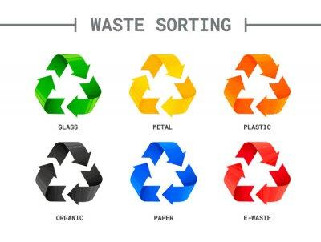

Organic, Glass, Metal, E-Waste, Plastic, Paper

B. Then, see the items below and say in which of these bins you would throw them.

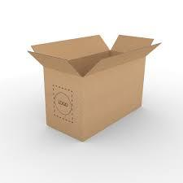
1.

2.

3.

1. Eggshells go in the organic bin
2. The lightbulb goes in the e-waste bin
3. The cardboard box goes in the paper bin

- Circle the correct answer.

- The greenhouse effect in a result of
a) Temperature fall
b) Temperature rise
c) has nothing to do with temperature

- What is the greenest way to travel to work or school?
- walk/bike
b) battery operated car
c) bus/train

- Circle ways to reduce your carbon footprint.
- Take shorter showers
- Eat healthy food
- Use solar panels to heat water
- Address to adults with respect
- Use public transport to go to work/school
- Be a better student at school

- Write T (for true) or F (for false).
a) We recycle paper in specified bins.
b) We prefer to use plastic bags rather than paper bags.
c) We reduce the amount of watering our plants during winter.

- Match.

1.
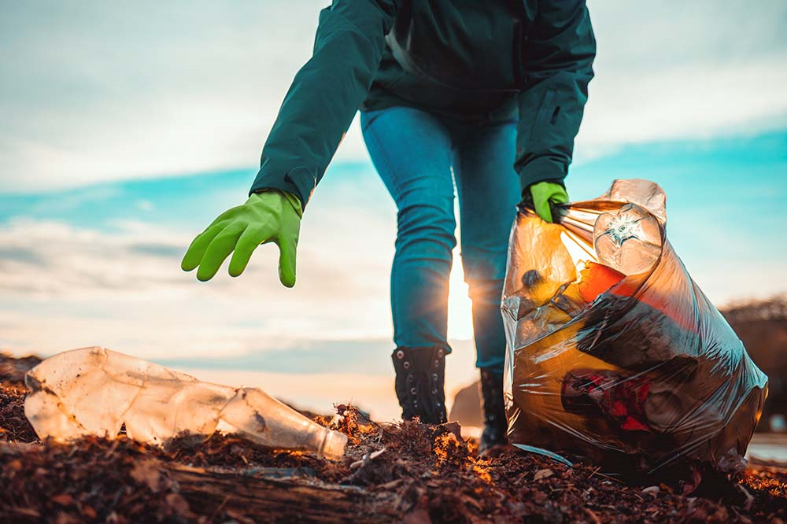
2.
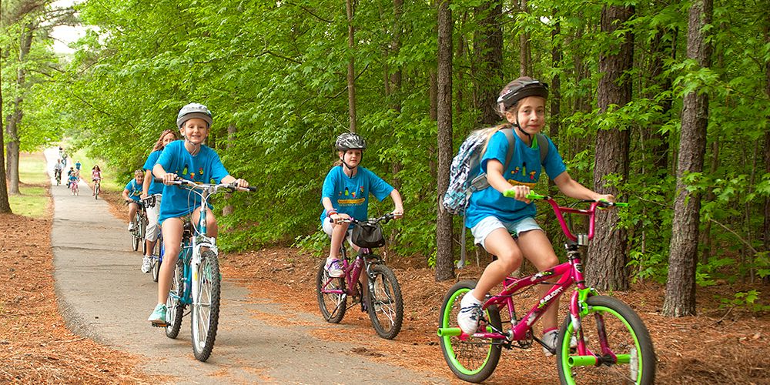
3.
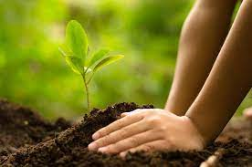
4.
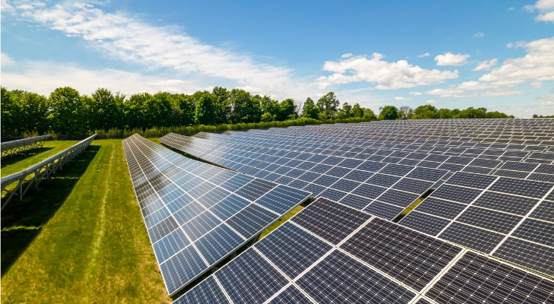

a) Planting new trees
b) Picking up rubbish
c) Save up energy by using solar panels
d) Go to school by bike

1….. , 2….. , 3….. , 4…..

- Non-recyclable materials: True-false:

- Milk cartons, juice cartons or pelts are recyclable: (F)
- Little pieces of paper are allowed to go in the blue bins: (F)
- Foam and Styrofoam cannot be recyclable because they are flammable materials: (T)
- Plastic bottle caps have the same recycling process as plastic bottles: (F)
- Glass must not be shuttered in order to be recycled: (T)
- Biodegradable and photo dissipative bags are recyclable: (F)

- Non-recyclable materials: Multiple choice:

- CDs and DVDs are:
a. recyclable
b. non-recyclable
c. biodegradable

B) Some non-recyclable materials are:
a. cans
b. glass bottles
c. aluminum foil

C) plastic bags can be recycled when they are:
a. biodegradable
b. plastic
c. photo dissipative

D) what can be dangerous when thrown in the blue bin:
a. aluminum cans
b. broken glass
c. plastic bottles

- Read the questions below and circle whether they are true or false.

- Plastic bottles are being recycled.
True False

- Used tissues shouldn’t be put in the trash.
True False

- Recycling pollutes the environment.
True False

- We need to remember to recycle water bottles, as they are quickly filling our landfills.
True False

- Cans and toys made out of metal are not recyclable.
True False

- Glass bottles and jars can be recycled.
True False

- Recycling is important because it reduces the amount of waste sent to landfills.
True False

- Recycling is the conversion of the waste material into useful material.
True False

- Match the products with the bins they should be put in.

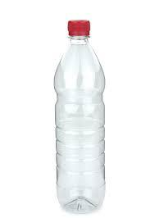

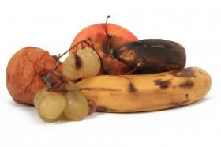
1) 2) 3) 4) 5)



a) b) c) d) e)
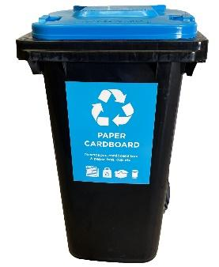
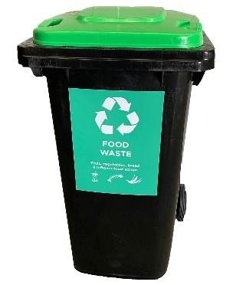
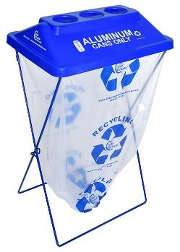
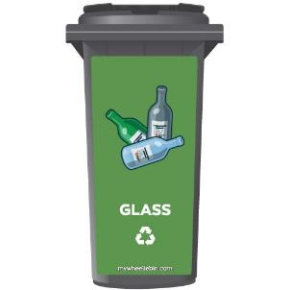
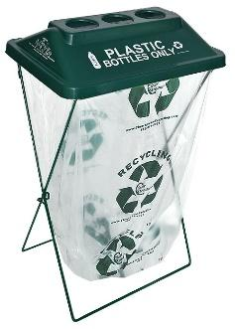

- True or False: Recycling

- Do cardboard boxes go in the regular bin? T or F
- Can a plastic bottle be recycled? T or F
- Is plastic good for the environment? T or F
- Does glass go in the regular bin? T or F
- Is the material of a can recyclable? T or F
- Are petrol and diesel bad for the environment? T or F
- Is carbon dioxide CO₂ good for humans? T or F
- Are the trees useful for the environment? T or F

- Match the correct pictures with the worlds.

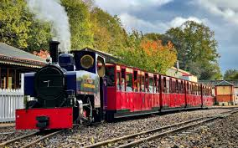

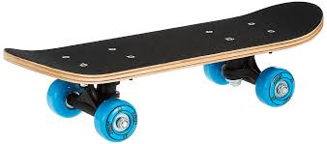
BICYCLE


CAR

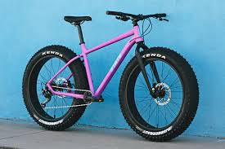
TRAIN

METRO

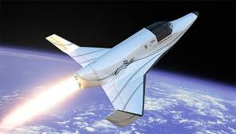

SKATEBOARD

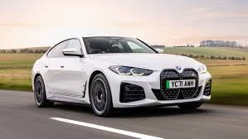
AIRPLANE

BALLOON


SPACESHIP

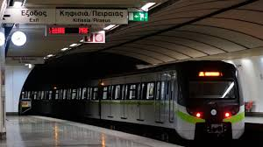

- Label the pictures.
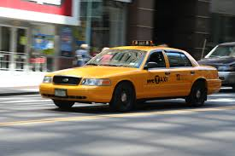
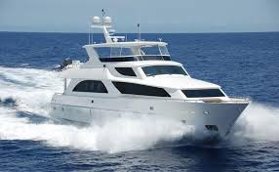


1._____________ 2. _________________ 3. ________________

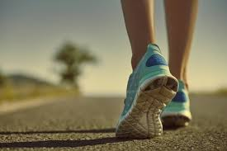
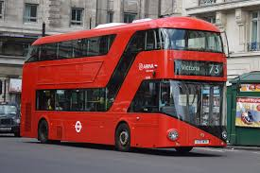
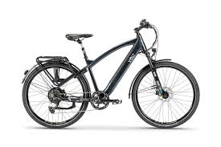

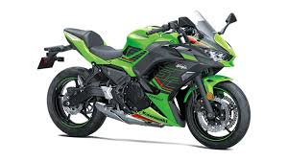
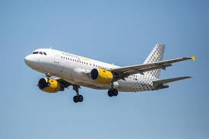
4. ________________ 5. _________________ 6.___________________

7.__________________ 8. __________________ 9. ________________

- Match the correct rubbish bin with the correct word:

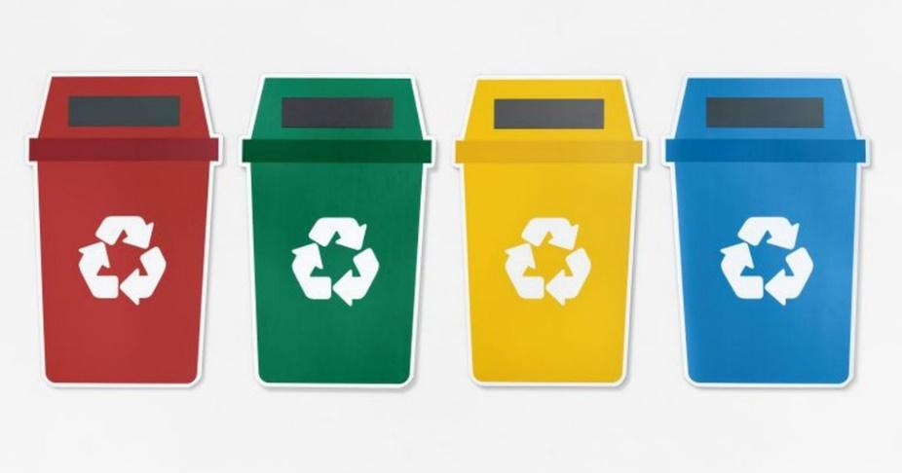

GLASS PLASTIC ALUMINIUM PAPER

- What are these images talking about? (Write a small sentence):

EX: 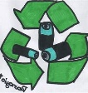 = This picture talks about recycling batteries

 = ______________________________________________________________

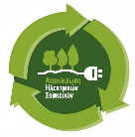______________________________________________________________

= ______________________________________________________________

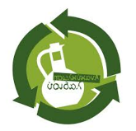

= ___________________________________________________

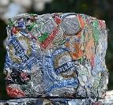 = _____________________________________________________________

 = _____________________________________________

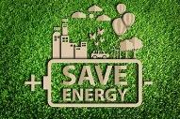 = __________________________________________

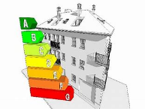=___________________________________________

 =___________________________________________

 = ___________________________________________

 = __________________________________________

- True – False

Lime is a green product R F
Stone is not a green product R F
Bamboo is not a green product R F
Plastic is not a green product R F
Wood is not a green product R F
Paper is not a green product R F

- When you hear the word environment what comes to your mind first. Check it out below.


- The rules for the following game are as follows:

you can go from two routes. The good, green, and the bad, red. One is short but dangerous because if any player rolls a 6 then all the players who are on the red route return to the starting point. Whoever reaches the finish line first wins. Have fun!
END

Logging
Metro

Quarry
Natural gas

Fires
Wind power

No chemical products

Oil spills
Water saving

Spray
Electric car

Waste of water
Solar power

START
Car
Plastic
Bicycle

Recycling
Tree planting
Reuse
Public transport

- Multiple Choice

1. What does the term "upcycling" refer to in the context of green products?
a) Recycling materials into new products
b) Donating old items to charity
c) Reusing materials to create products of higher value
d) Using fewer resources in product manufacturing

2. Which of the following is a characteristic of a sustainable product?
a) Designed for single-use only
b) Made from non-renewable resources
c) Produced with minimal environmental impact
d) Packaged in excessive plastic

3. What is the primary goal of a "carbon offset"?
a) To increase carbon emissions
b) To neutralize or compensate for carbon emissions
c) To ignore environmental concerns
d) To reduce the use of renewable energy

4. Which type of light bulb is considered more energy-efficient compared to traditional incandescent bulbs?
a) Incandescent bulbs
b) Halogen bulbs
c) Compact fluorescent bulbs (CFL)
d) LED bulbs

5. What is the purpose of the "Fair Trade" label on a product?
a) Indicating the product is made with minimal effort
b) Guaranteeing the lowest possible price for consumers
c) Ensuring fair wages and ethical treatment for producers
d) Signifying a product is only available for trade, not for purchase
6. Which of the following materials is biodegradable?
a) Plastic
b) Glass
c) Aluminum
d) Compostable plastic

7. What does the recycling symbol with a number inside represent on plastic products?
a) The product is not recyclable
b) The type of plastic resin used in the product
c) The product is biodegradable
d) The product is made from recycled materials

8. Which of these practices contributes to water conservation in agriculture?
a) Over-irrigating crops
b) Using chemical fertilizers excessively
c) Implementing drip irrigation systems
d) Ignoring soil erosion

- The Veggie Burger Make

Follow the veggies (vegetable) to make the Veggie Burger!
START
CHICKPEAS
CHOCOLATE
BREAD
CHICKEN
GARLIC
BISCUIT
PIZZA
SWEETPOTATO
PEAS
SPAGHETTI
CHEESE
CORN

FINISH



- Answer the following questions on recycling.

- Which one is recyclable ?
  - Paper
  - Batteries

- Is Glass Recyclable ?
  - Yes
  - No

- Are Paper towels Recyclable ?
  - Yes
  - No

- Plastic is always recyclable.
  - True
  - False

- Which one is recyclable ?
  - Styrofoam
  - Cardboard

- Are Newspapers recyclable ?
  - No
  - Yes

- Mark True or false (transportation)

- To reduce environmental pollution, everyone must use their car. ___

- There are no electric cars. ___

- we should all use the traffic code. ___

- Buses carry a lot of people so gas is saved. ___

- By using the ships we help with cleanliness of the sea. __

