

**GreenGame**

**Teacher’s Handbook**

**The Adventures of an Ecological Hero**

**Contents**

**1.** **Introduction** 2

**2.** **Teacher´s Handbook Purpose** 4

**3.** **Serious Game in Teaching-Learning** 6

**3.1 Some elements contribute to both the entertainment value and the effectiveness of its serious purpose:** 7

**3.2 Advantages of using a serious game in teaching:** 8

**4.** **Education Goals and Learning Outcomes** 8

**5.** **Green Game – The Adventures of an Ecological Hero** 14

**5.1** **Pre-Game Preparation: Gameplay Basics and Getting Started** 14

**5.2** **Games Scenarios/Themes** 16

**5.2.1** **Step by Step** 16

**5.3** **Progression and Rewards** 23

**5.4** **Ending the game** 23

**5.5** **Troubleshooting** 24

**6.** **Curricula Integration** 26

**7.** **Instructions for Pilot Testing** 30

**Teachers’ feedback questionnaire** 31

**Bibliography and References** 33

The publication has been produced within the Erasmus+ Strategic Partnership in school education “**GreenGame** - Pro-environmental behaviour development for school-age children” (2022-2024) financed by the European Union.

**The partnership includes:**

- Creative Ideas (Latvia)

- INSTITOUTO EREFNAS KAI THERAPIAS TIS SIMPERIFORAS (Greece)

- União das Freguesias de Gondomar (S. Cosme), Valbom e Jovim (Portugal)

- Akademia Humanistyczno-Ekonomiczna w Lodzi (Poland)

- DEP INSTITUT (Spain) un Arsakeio Gymnasium Patras (Greece)

Project website: [greengamepro.eu](https://greengamepro.eu/)

The European Commission’s support for the production of this publication does not constitute an endorsement of the contents, which exclusively reflect the views of the authors, and the Commission cannot be held responsible for any use which may be made of the information contained therein.



… [name] is licensed under a Creative Commons Attribution 4.0 International License.

# **Introduction**

Climate change and environmental degradation are seen as a big threat in Europe. While government policies and actions aim to raise awareness about sustainable development and promote healthy lifestyles, just raising awareness is not enough.

**GreenGame** project aims to support children (10-14 years old) to engage in pro-environmental behaviours and to achieve an environmentally friendly way of living, by establishing an enhanced degree of motivation, willingness, autonomy and commitment and to assist teachers in stimulating pro-environmental behaviour to their students.

The GreenGame project comprises a psychoeducation program aimed at fostering the development of pro-environmental behaviours in school children aged 10 to 14. Grounded in mindfulness and awareness-raising interventions, the program seeks to promote a proactive stance toward pro-environmental behaviour. Facilitated by new technologies, this process focuses on self-regulation and self-control. The project addresses seven key themes: recycling, water conservation, electricity saving, reusing, transportation/mobility, disposal of non-recyclable waste, and consumption of green food products.

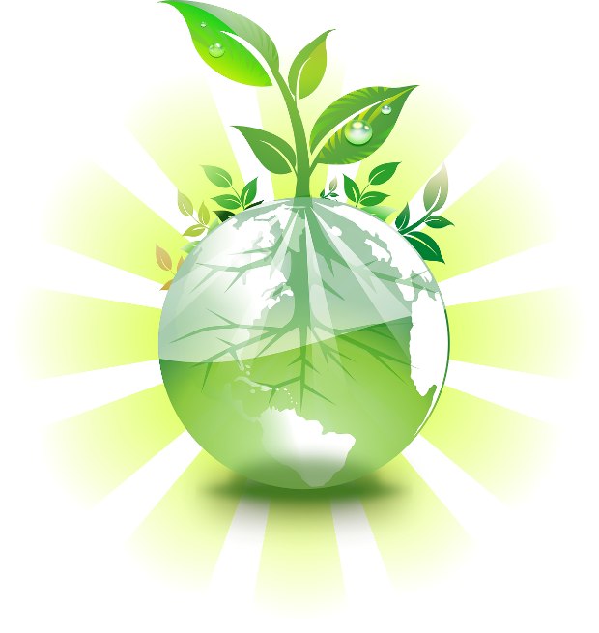

It also consists of a pro-environmental behaviour serious game that includes empowerment and motivation enhancing interventions for habit formation and change, focusing on linking individual behaviour change with overall social benefit. This serious pro-environmental game is addressed in this Handbook as well as in the Student´s Handbook.

The **GreenGame** pro-environmental behaviour innovative game includes empowerment and motivation enhancing interventions for habit formation and change, focusing on linking individual behaviour change with overall social benefit.

The overall priority is to expand on the competences to fight against climate change.

“The European Green Deal, the EU Biodiversity Strategy for 2030, the United Nations Educational, Scientific and Cultural Organization (UNESCO) strategy Education for Sustainable Development for 2030 and the related United Nations Economic Commission for Europe (UNECE) work, highlight the **key role of schools, higher education and other education and training institutions in engaging with learners, parents, educators and the wider community on the changes needed for a successful, just and inclusive green transition**. In its conclusions on ‘Biodiversity – the need for urgent action’, the Council stressed thatinvesting in education, among other areas, is key in gathering the best data and finding the best solutions in this regard. The EU Youth Strategy identifies a sustainable green Europe as a goal and calls **for all young people to be environmentally active and educated**.” [1]

The reason for this Handbook, is to assist, support and help teachers, trainers, school leaders and other teaching professions in promoting competences and skills to stimulate pro-environmental behaviour in their students.

Teaching sustainability thinking skills will be useful to students who want to contribute to a sustainable future when they are operating in context: thinking drives behaviour and behaviour causes results.

*“****Sustainability education aims to provide learners with sustainability competences*** *in order to reflect and* ***embrace sustainability in their daily lives*** *as students, consumers, producers, professionals, activists, policymakers, neighbours, employees, teachers and trainers, organisations, communities, and society at large.”* [2]

# **Teacher´s Handbook Purpose**

This Handbook is directed at teachers, trainers, school leaders and other teaching professions.

This Handbook is an educational resource that intends to provide comprehensive information on the various environmental issues addressed in the game, such as recycling, conserving water, saving electricity, reusing, transportation/mobility, disposing of non-recyclable waste, and consumption of green food products.

It provides guidance on how to introduce the game, set learning objectives, and align it with curriculum standards. It can also help with the planning of the lessons, helping teachers integrate the game into their lesson plans effectively.

The Handbook provides gameplay instructions: step-by-step instructions on how to play the game - the game mechanics, scenarios, controls, objectives, etc. - ensuring that teachers have a thorough understanding of the gameplay so they can help, support and guide their students. It also ads supplementary activities and tips to extend the learning beyond the game.

Along with the other materials and activities, this Handbook, allows for thinking, discussion and questions related to the game's themes and challenges. These prompts can encourage meaningful conversations among students, allowing them to reflect on their actions in the game and connect them to real-world environmental issues.

Overall, the teacher's Handbook serves as comprehensive support material for educators, enabling them to maximize the educational impact of the serious game and facilitate meaningful learning experiences related to conserving resources and protecting nature in general and, specifically about recycling, conserving water, saving electricity, reusing, transportation/mobility, disposing of non-recyclable waste, and consumption of green food products.

Experiencing sustainability (experiential teaching-learning) is essential to stimulate a change in mindset. This can in turn promote action in a change in consumption patterns.



**The end goal of an education for sustainability is when the school grounds are seen as a microcosm of the larger community and function as an outdoor classroom**; when student projects focus on real life community needs and community resources enhance student learning; when students meet curriculum learning goals by initiating and participating in real-life problem-finding and problem-solving projects that directly benefit the community outside the school. This helps students see why **the curriculum skills and knowledge are important to real life situations, and helps them transfer what they have learned to different contexts** while simultaneously bringing student resources to real community improvement.

# **Serious Game in Teaching-Learning**

Serious games are games that have another purpose besides entertainment; they aim toward problem-solving. They can help learners gain a good understanding of a specific topic and sustain the acquisition of complex competencies. They also integrate the students as key pieces in the teaching-learning process.

Serious games have more than just story, art, and software. It is the addition of pedagogy - activities that educate or instruct, thereby imparting knowledge or skill - that makes the games “serious”.

The power of serious games is that they are entertaining, engaging and immersive.

Serious games combine learning strategies, knowledge, structures, and game elements to teach specific skills, knowledge and attitudes.

They are designed to solve problems in several areas and involve challenges and rewards, using entertainment and engagement components provided when the user is playing the game.

It´s effective as a tool because it establishes higher engagement (motivates the player to keep on playing by using rewards, story progression or other feedback systems) and it´s fun, so learning is improved by positive emotions.

It has the potential of improving training activities by virtue of, e.g., its engagement, motivation, role playing, and repeatability (failed strategies/actions can be altered and tried again).

**Some characteristics of a serious games include:**

* Purpose: they are designed with a specific educational, training, or informational purpose in mind;
* Goals: they have defined learning or behavioural objectives that players are expected to achieve through gameplay;
* Engagement: they aim to capture and maintain the player's interest and motivation by providing an enjoyable gaming experience;
* Feedback and assessment: serious games often offer feedback mechanisms to provide learners with information on their progress and performance;
* Simulations and interactivity: they simulate real-world scenarios or systems and allow players to interact with the game environment and make decisions;
* Adaptability: some serious games adapt to the player's actions and adjust the difficulty level or content based on their performance.

## **3.1 Some elements contribute to both the entertainment value and the effectiveness of its serious purpose:**

* Interactivity - gameplay: the decisions and actions a player has to take to overcome challenges;
* Progression and feedback - challenges and rewards: there are different progression systems to be able to engage and retain players from all skill levels and some games adapt the difficulty automatically to the player. Besides matching the challenge with the skill level, games are also very rewarding. When a player conquers a certain challenge, this triggers a release of endorphins which makes the player feel better about themselves. Players will want to keep on playing to keep the endorphins flowing. Contrary to one-way learning experiences (e.g. books, videos), in games the player can interact with the subject matter. This allows the player to experiment different outcomes of their actions. This is the very nature of how humans learn;
* Social aspect - multiplayer: learning in groups is more effective than learning alone. Being able to play or compete with other players is one of the motivations for people to play and continue playing games. The interaction creates unpredictable situations which in turn can create interesting challenges or funny situations. Being able to compete or cooperate with other players, improves both learning and engagement. Kids learn by interacting and experimenting.

## **3.2 Advantages of using a serious game in teaching:**

* Fixation of concepts already learned in a way that´s motivating for the student;
* Introduction and development of concepts difficult to understand;
* Development of problem solving strategies problems (game scenarios/challenges);
* Learn to make decisions and know how to evaluate them;
* Make decisions and bear the consequences of those decisions;
* Gives significance for apparently incomprehensible concepts;
* Requires the active participation of the student in the construction of their own knowledge;
* Favours socialization between students and awareness of teamwork when there´s a multiplayer option;
* Favours the development of creativity, critical thinking, participation, sound competition and observation;
* Can be used to reinforce or recover skills students need;
* Allows the teacher to identify, diagnose some learning errors, students' attitudes and difficulties.

# **Education Goals and Learning Outcomes**

**This project seeks to cultivate environmentally responsible behaviour among school children** **by emphasising self-regulation, self-control, and the integration of innovative technologies**. The following represents educational objectives and expected learning outcomes for this endeavour:

**Educational Goals:**

Environmental Awareness: To increase students' understanding of environmental issues and the impact of individual behaviours on the environment.

Pro-Environmental Attitudes: To foster positive attitudes towards environmental sustainability and the importance of conservation.

Behaviour Change Skills: To equip students with the necessary skills to initiate and sustain pro-environmental behaviours.

Self-Regulation: To promote self-regulatory skills that enable students to monitor and adjust their behaviours to align with pro-environmental goals.

Technology Integration: To familiarise students with advanced ICT technologies and their role in promoting sustainable practices and behaviour change.

Empowerment and Motivation: To empower students to take ownership of their actions and understand the positive impact of their individual behaviours on the broader social and environmental context.



**Learning Outcomes**:

Improved Environmental Knowledge: Students should demonstrate a more comprehensive understanding of environmental issues and their implications.

Increased Pro-Environmental Behaviours: Students should exhibit a measurable increase in engaging in environmentally friendly activities both at school and at home.

Enhanced Self-Regulation: Students should demonstrate improved self-regulatory skills, leading to more consistent and sustainable pro-environmental behaviours.

Technology Proficiency: Students should develop competence in using advanced ICT technologies to support their environmental learning and behaviour change efforts.

Empowered Decision Making: Students should be able to make informed decisions that prioritise environmental sustainability and demonstrate a sense of responsibility towards the environment.

Social Awareness: Students should recognize the interconnectedness of individual actions with the well-being of the community and the planet.

**Teachers play a critical role in supporting students to achieve the educational goals and learning outcomes related to pro-environmental behaviour**:

Integrating Environmental Education: To incorporate environmental education into the curriculum across various subjects, helps highlight the importance and applicability of sustainable practices and their impact on the environment.

Facilitating Discussions: To encourage students to open discussions and debates about environmental issues, allowing them to express their thoughts, concerns, and ideas freely, acting as a moderator.

Providing Real-World Examples: Using real-world examples and case studies to illustrate the impact of human actions on the environment, can demonstrate the significance of individual contributions to environmental conservation.

Encouraging Critical Thinking: Prompting students to analyse complex environmental problems, assess potential solutions, and evaluate the consequences of different courses of action fosters critical thinking skills.

Integrating Technology: The use of advanced ICT technologies within the classroom as a tool to enhance students' understanding of environmental issues, promote interactive learning experiences, and provide access to digital resources that facilitate self-paced learning and exploration.

Setting an Example: Serving as a model for students in pro-environmental and sustainable behaviour and practices, serves as an example to adopt of how small changes in daily routines can contribute to a more sustainable lifestyle.

Providing Support and Guidance: Be available to offer guidance and support to students as they face challenges related to this change in behaviour, self-regulation and the adoption of new environmentally friendly habits.

|  |  |
| --- | --- |
| **STUDENTS´ EDUCATIONAL GOALS** | **TEACHERS´ LEARNING OUTCOMES** |
| **Content Knowledge** | |
| a. Acquisition of knowledge about key environmental concepts. b. Deepen and apply the understanding of environmental issues. | a. Help your students develop a better understanding of various environmental concepts and sustainable practices, such as mobility and pollution, green consumption in general and green eating in particular, renewable energies, saving water and electricity, reusing and recycling.  b. Transfer knowledge (active and deep learning) - optimal education experience. |
| **Critical Thinking Skills** | |
| a. Development of critical thinking skills.  b. Analysis of information, option´s evaluation, informed decision-making, and weighing the consequences of one's choices. | a. Present students with environmental challenges and dilemmas within the subjects.  b. Help them with analysis, problem-solving, and decision-making, needed for those challenges and dilemmas. |
| **Problem-Solving Abilities** | |
| a. Enhance students' problem-solving abilities.  b. Identify problems, brainstorm potential solutions, and implement strategies. | a. Engage students in the game's environmental scenarios.  b. Understand the benefits of game-based learning, a teaching-learning method that will encourage them to identify problems, brainstorm solutions, and implement strategies to address environmental issues effectively. |
| **Awareness and Empathy** | |
| a. Awareness of environmental problems.  b. Foster empathy for the natural world.  c. Appreciation of the value of nature. | a. Raise awareness, through gameplay and storytelling, about environmental problems and inspire empathy for the natural world.  b. Teach them about the interdependence between humans and nature, realizing the impact their actions have on the environment and other species and broaden the understanding of the interconnectedness of ecosystems and human activities.  c. Help the students develop a sense of responsibility and stewardship. |
| **Collaboration and Communication** | |
| a. Collaboration among peers, family and community.  b. Development of communication skills. | a. Promote collaboration and develop communication skills among players.  b. Emphasize the importance of teamwork, cooperation, sharing ideas, and considering diverse perspectives to address environmental challenges collectively. c. Share experiences, discuss strategies within a network of colleagues, researchers, and experts in the field of environmental education that learn from each other and strengthen the collective knowledge base.  d. Promote a supportive professional community focused on environmental education and contribute to the development of best practices in game-based environmental education. |
| **Action and Behaviour Change** | |
| a. Action in their own lives and within their communities.  b. Adoption of sustainable behaviours.  c. Advocate for positive change. | a. Motivate students to take real-life actions to protect the environment and advocate for green change.  b. Foster and encourage sustainable behavioural changes and habits: encourage students to apply what they've learned to their daily lives. |
| **Technology Skills** | |
| a. Apply technology skills in using meaningful educational technology tools to then usefully apply that learning on daily lives. | a. Be aware of the successful use of digital serious games as a learning resource.  b. Become competent in using educational technology tools.  c. Utilize and incorporate technology into teaching practices (technology integration).  d. Develop skills in navigating educational technology platforms, managing virtual environments, and effectively utilizing game-based learning.  e. Be empowered to harness the potential of technology for impactful environmental education. |
| **Cross-Curricular Connections** | |
| a. Acquire overall knowledge trough interdisciplinary learning. | a. Identify opportunities to connect the game's content and issues with different disciplines (integrate the game into existing curricula).  b. Facilitate the integration of the game into various subjects and curricula, promoting interdisciplinary learning and reinforcing learning across different disciplines. |
| **Reflection and Self-assessment**  a. Reflection about individual and shared experience and knowledge. | **Reflection and Self-assessment**  a. Use the serious game as a starting/ending point to discuss environmental issues.  b. Encourage students to reflect on their gaming experience.  c. Provide opportunities for self-assessment, discussion, insight sharing, and reflection on the knowledge gained, skills developed, and personal growth achieved through the game.  d. Promote critical thinking and reflection on environmental issues.  e. Critically examine one´s own approach to environmental education and identify areas for improvement.  f. Reflect on ones´ environmental attitudes, behaviours, and teaching practices.  g. Explore alternative assessment strategies for evaluating by analysing students decision-making processes as indicators of their understanding and application of environmental concepts. |
| **Real-World Application** | |
| a. Application of knowledge and skills to the real-world. b. Engage in practical projects and community actions. | a. Maximize the knowledge transfer so that information acquired can be re-used at a later stage by the students.  b. Encourage the students to engage in practical projects or community actions that contribute to environmental sustainability.  c. Enable students to apply the knowledge and skills acquired from the game to real-world environmental issues. |

# **Green Game – The Adventures of an Ecological Hero**

GreenGame is an exciting online gaming experience that blends mindfulness, environmental consciousness, and interactive challenges. As players embark on a two-week journey, they become the heroes of their own story, navigating through various environmental spheres and adopting sustainable practices in their daily lives.

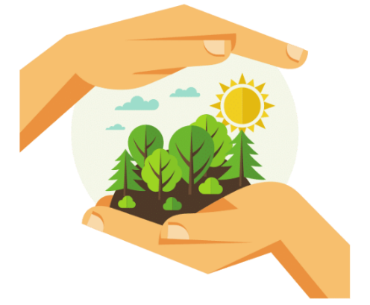

Guided by a set of intentions and daily goals, students travel into seven key thematic areas, including recycling, water conservation, energy-saving, and eco-friendly commuting. By accomplishing these tasks, players earn valuable points that contribute to their progress. Every successful completion brings them closer to their ultimate mission: to protect the environment and make a positive impact on the world.

The game's interface offers a visually engaging 2D animation experience. Within this immersive environment, players interact with specially designed characters, explore vibrant backgrounds, and engage in a variety of challenges tailored to promote sustainable behaviours.

Amidst the gameplay, players can communicate and collaborate with their peers, exchanging experiences and insights on the critical issues at hand. Through this shared learning experience, they not only build a deeper understanding of sustainability but also foster a sense of community and collective responsibility.

With a different approach to education and gaming, GreenGame stands out as a proactive initiative, offering a unique blend of entertainment and environmental awareness. By empowering the younger generation with knowledge and practical tools for sustainability, the game aims to spark a transformative impact, cultivating a generation of mindful, eco-conscious individuals dedicated to shaping a greener, more sustainable future.

## **Pre-Game Preparation: Gameplay Basics and Getting Started**

In this section, we'll cover the fundamentals of the game, how to start integrating it into the classroom and how to prepare for an engaging and educational learning experience.

The development of the Green Game was designed to engage students in a playful and interactive way, transcending the mere pursuit of entertainment by embracing a critical educational purpose. More than just a recreational experience, this game was created with the specific purpose of promoting pro-environmental behaviour and environmental awareness.

By positioning itself as a powerful educational tool, the Green Game plays a crucial role in helping to develop students' environmental competences. Through engaging challenges and scenarios, students not only absorb knowledge, but internalise fundamental concepts related to sustainability. This unique approach allows learning to take place organically, using play as a highly effective means of conveying information and stimulating active participation.

As well as strengthening understanding of the importance of sustainability, the Green Game goes further, contributing to the development of cognitive, emotional and social skills. Students are challenged to improve skills such as problem-solving, collaboration and informed decision-making as they navigate the different levels of the game. Therefore, the Green Game not only educates, but also cultivates a comprehensive set of skills that are essential for face real-world environmental challenges.

The teacher, together with the students, should have in mind of their commitment to environmental education and sustainability, as discussed above. The serious game should be presented as a challenge that will help consolidate the knowledge students have acquired during the psycho-educational programme.

It is essential to provide a comprehensive overview of the game, elucidating its objectives and the educational significance it embodies. The game's integration of environmental awareness and interactive challenges is aimed at fostering pro-environmental behaviours in a clear delineation.

Establishing clear expectations for both teachers and students involves outlining the learning outcomes, delineating the role of the game in fostering environmental awareness, and highlighting the importance of active participation. Is crucial that that everyone comprehends the goals and benefits of this experience.

Teachers and students should imagine themselves being transported to a virtual world where the destiny of the environment is in your hands and, while having fun, learn how to apply sustainable environmental practices explored together in the previous practical activities.

As students progress through the levels of the game, they will encounter challenges that reflect real-world sustainable practices. They will need to apply the strategies and knowledge they have acquired during the programme to overcome obstacles and make responsible decisions.

Every choice made will contribute, will contribute to the preservation of the virtual ecosystem, just as we have learnt to do with our real planet.

Students took part in various activities, from recycling to reducing energy consumption. This game is an extension of those experiences, an opportunity to put what they've learnt into practice. As they solve the challenges, pro-environmental behaviours discussed and practised are being strengthened.

What's more, at the end of each level comes the opportunity for reflection, where students can freely discuss the choices they've made in the game and relate them to the actions we can take in our own lives. This isn't just a game, it's a simulation of the real world, an opportunity to shape the future of our environment and understand how small individual actions can have a significant collective impact.

Students should get ready for an exciting and educational journey. This is the time to apply everything they've learnt and show that, they, we can be agents of change for a more sustainable future. Good luck! And may virtual environmental challenges become real achievements for our planet.

## **Games Scenarios/Themes**

In the world of GreenGame, the concept of game scenarios or themes is fundamental to creating an engaging and educational gaming experience. These scenarios or themes provide a framework for students to explore environmental issues and learn how to adopt sustainable behaviours.

GreenGame is divided into seven distinct "environmental spheres," each representing a unique environmental theme or scenario. These spheres serve as the focal points for students' exploration and learning.

Within the recycling sphere, students dig into the world of responsible waste management and recycling practices. They learn about the importance of reducing, reusing, and recycling materials to minimize environmental impact.

The water conservation sphere focuses on the precious resource of water. Students discover the significance of conserving water, addressing issues like water lack and the impact of everyday water usage.

In the energy-saving sphere, students explore energy efficiency and responsible energy consumption. They learn about sustainable energy sources and how to reduce their energy footprint.

This sphere encourages students to consider alternative transportation methods that are environmentally friendly. They explore topics such as walking, biking, carpooling, and using public transportation to reduce emissions.

Students gain insights into the consequences of climate change and the global actions needed to mitigate its effects. While progressing through the game, students are encouraged to adopt an overall sustainable lifestyle.

These game scenarios or themes provide a framework for students to explore and understand complex environmental issues. By immersing themselves in these scenarios, students gain insights into the interconnectedness of environmental challenges and are empowered to make a positive impact on the world. As a teacher, you play a crucial role in guiding students through these themes and helping them become environmentally conscious individuals who can shape a more sustainable future.

### **Step by Step**

1. Open the game and complete the daily task.

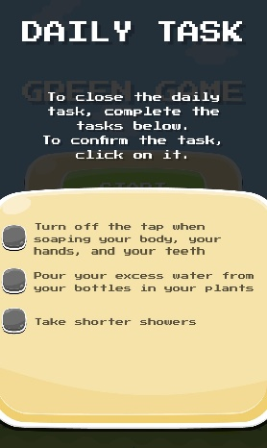

1. 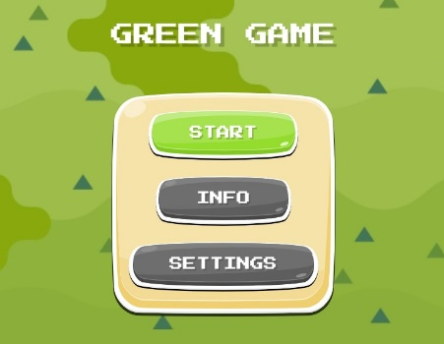Click on the Setting button to choose our language, then click on the Start button.
2. By pressing the Start button, we have access to the different levels in the window below:

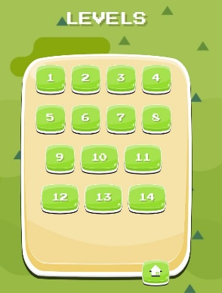

1. Whenever you want to go back to the previous menu, you can do it using the button shown below. This button is available at all times during the game (before the instructions, in the level window and during the game).

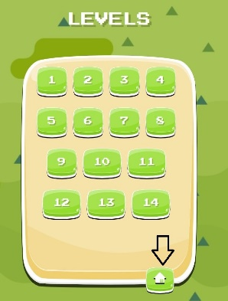

1. 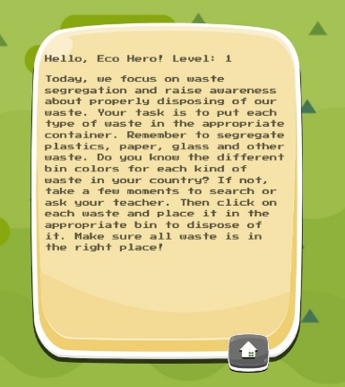By clicking on a level, we have access to the instructions for the task to be performed.
2. Once the task has been checked, we can start the game by clicking on the Start button.

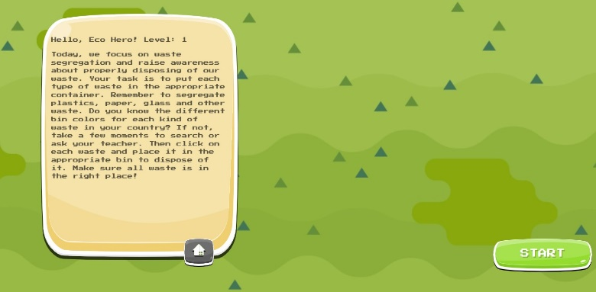

1. Starting the game at level 1, we have the task of placing the items in the correct colour container (blue, green, yellow, grey and brown). We have 60 seconds to do this.

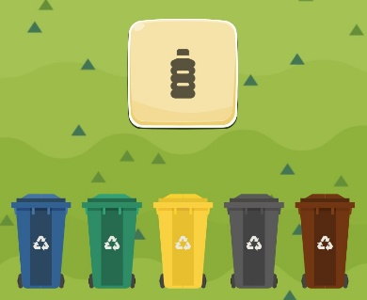

1. Level 2 is about planting trees in 30 seconds. To do this, you have to drag the trees to the place to be planted.

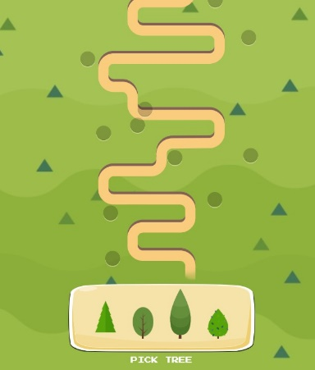

1. In level 3 we are asked to answer 4 questions and we have 30 seconds to do so.

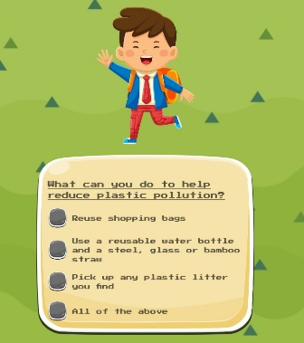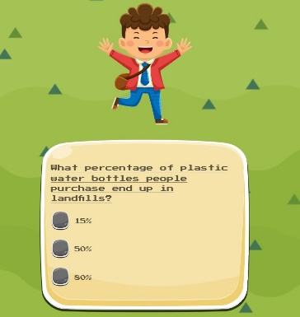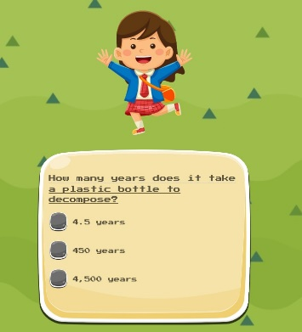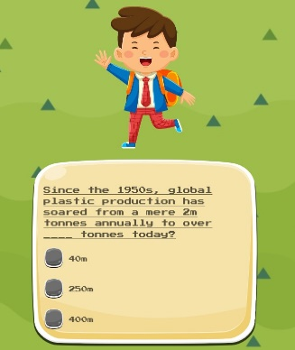

1. In level 4 you have to prevent people from reaching the tree by clicking on each one to make it disappear. We have 30 seconds to do it.

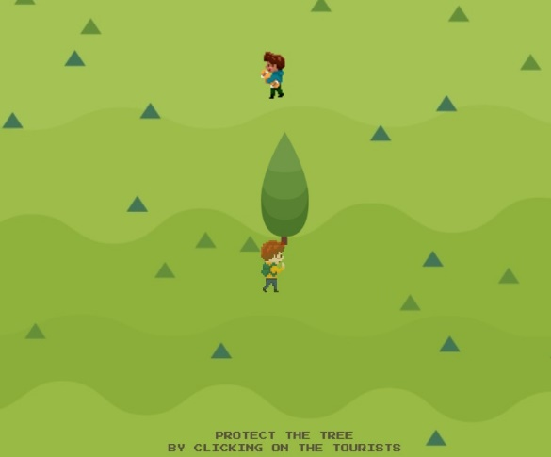

1. Level 5 is about correctly choosing the healthiest foods from a range of options. We have 60 seconds to do it .

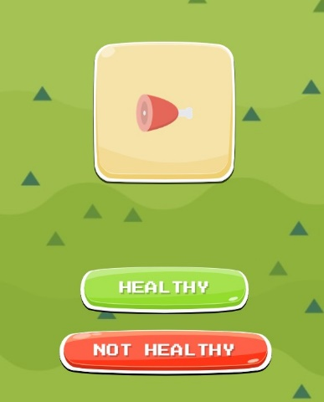

1. The aim of level 6 is to clean up the river by clicking on the rubbish to make it disappear. We have 60 seconds do do it.

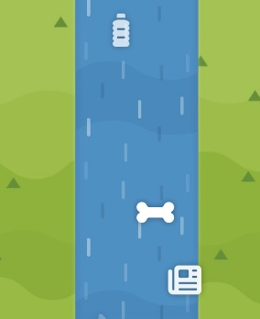

1. Level 7 aims to organise the means of transport from the most environmentally friendly to the least. When you enter the level, 4 questions appear for you to answer and you have to select the correct answer. We have 30 seconds to accomplish it.

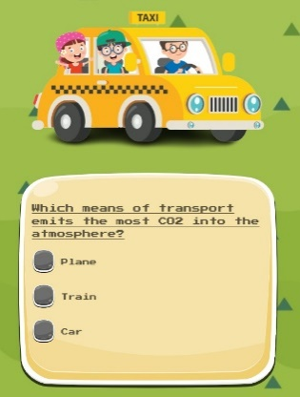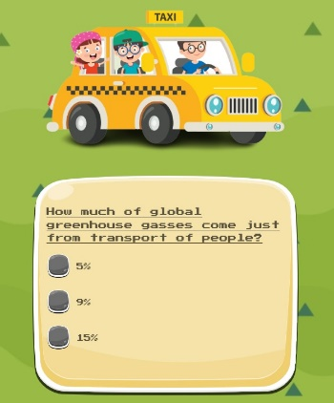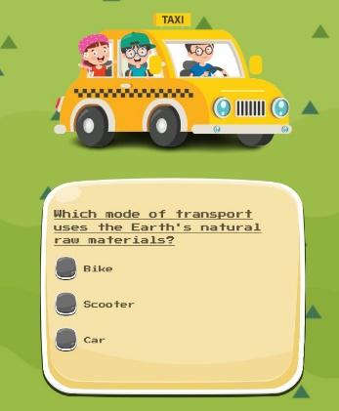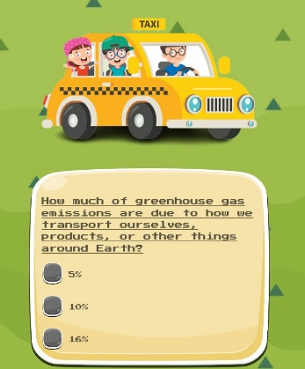

1. In level 8 we have to select the correct option in relation to the question posed, there is also the option of none of the answers being correct and selecting none of the above. We have 60 seconds to do it.

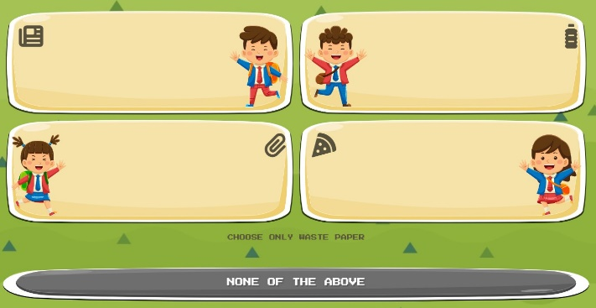

1. In level 9 you have to answer 4 questions by choosing the correct option. There is no time to do it.

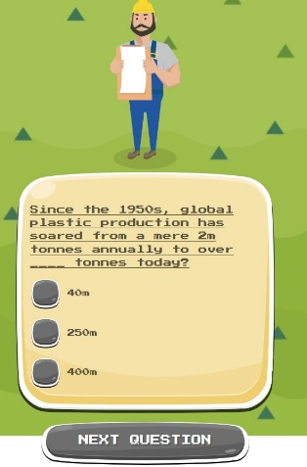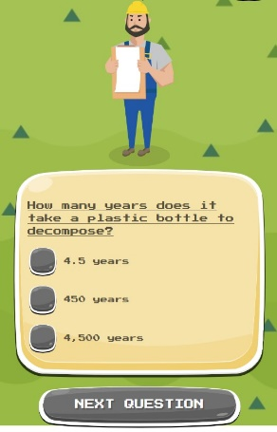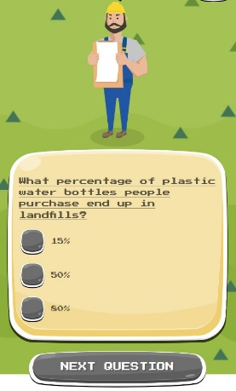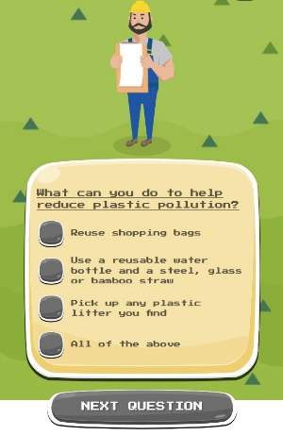

1. At level 10, when you start the game, you have to select what is eco-friendly and not eco-friendly from various product options (recyclable bags, electric car, electric scooter, reusable cup, CO2, pouring liquids into the sea, solar panels, ecological lights). It lasts 60 seconds.

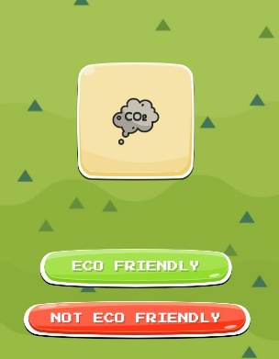

1. On level 11 you have to answer 4 questions to choose the correct option. There is no time to do it.

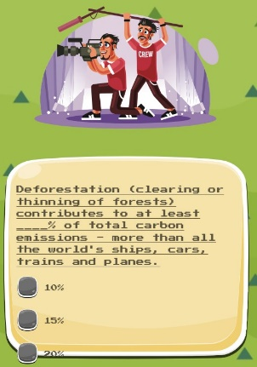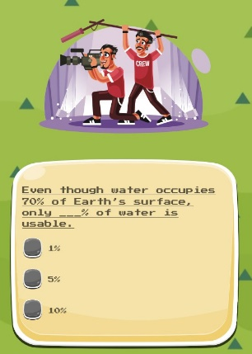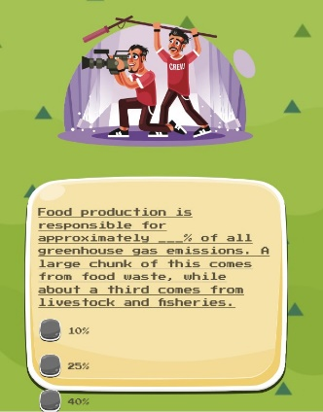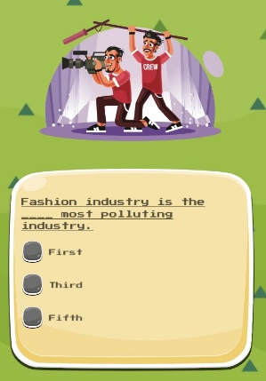

1. On level 12 you have to answer 2 questions to choose the correct option. There is no time to do it.

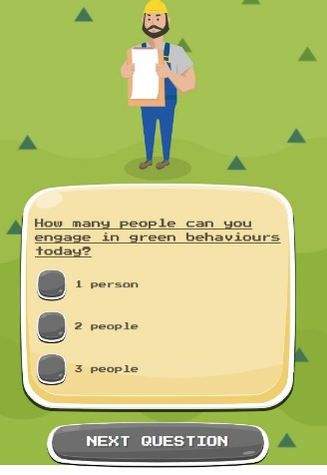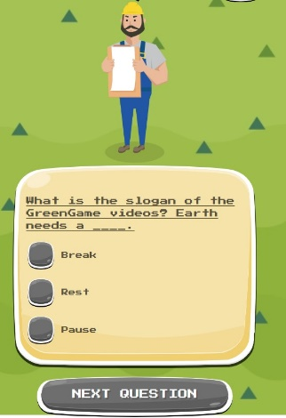

1. On level 13 the aim is to drag the trees onto the board to plant them in the right place. We have 30 seconds to do it.

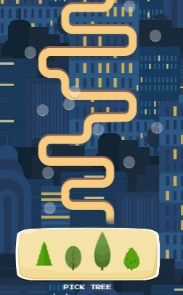

1. On level 14 you have to answer 4 questions to choose the correct option. There is no time to do it.

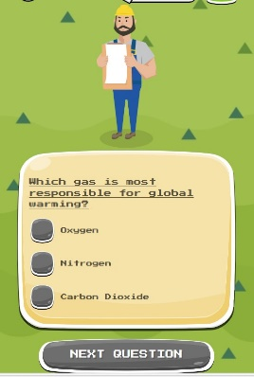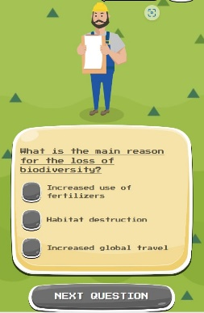

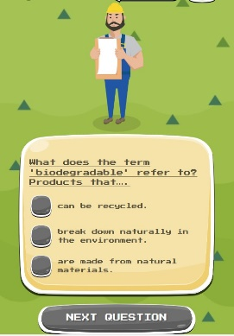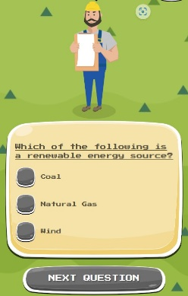

1. At the end of each level there's always a good job window.

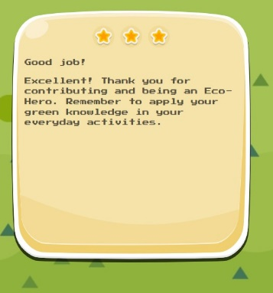

1. Regarding the qualification, you will have 1, 2 or 3 stars at the top of the good job window.

## **Progression and Rewards**

In the GreenGame experience, progression and rewards are essential elements that motivate and engage students on their journey toward environmental awareness and pro-environmental behaviours. As a teacher, understanding how these components work can help you guide your students effectively through the game's immersive world. Here's a closer look at how progression and rewards play a crucial role in GreenGame:



GreenGame divides the environmental journey into seven thematic areas, each represented as an "environmental sphere." These themes incorporate essential topics like recycling, water conservation, energy-saving, and eco-friendly commuting.

As students advance through these domains, they gradually build a deeper understanding of diverse environmental issues and corresponding sustainable practices.

To progress, students set daily goals aligned with each sphere. By successfully completing these goals, they earn points that contribute to their progress.

Achievements are celebrated as students accomplish specific tasks, reinforcing their commitment to sustainable behaviours. GreenGame employs a rewarding points system designed to incentivize and motivate students.

Importantly, the skills and knowledge gained during gameplay can be applied in real life. Students are encouraged to transfer their sustainable behaviours outside the game, fostering a lasting impact.

By immersing themselves in the game's progression system, students not only acquire knowledge but also develop a genuine commitment to making a positive impact on the environment. As a teacher, you play a vital role in guiding them through this transformative journey, turning gameplay into real-world actions for a more sustainable future.

## **Ending the game**

As students embark on their two-week environmental journey within GreenGame, it's essential to prepare them for the conclusion of this transformative experience. Ending the game is a crucial part of the process, and as a teacher, you play a vital role in helping students reflect on their achievements and carry their eco-conscious behaviours forward.

Take time to celebrate and acknowledge the students' accomplishments throughout the game. Recognize their efforts in adopting sustainable behaviours and raising their awareness of environmental issues. Encourage students to reflect on their journey and discuss the changes they have made in their daily lives. Create a safe space for students to share their thoughts, feelings, and experiences.

Emphasize the importance of applying the knowledge and behaviours learned in GreenGame to real-life situations. Encourage students to continue their eco-conscious actions beyond the game and help them identify the sustainable habits they have developed, such as recycling, conserving water, reducing energy consumption, and using eco-friendly transportation.

Guide students in making a commitment to a greener, more sustainable future and encourage them to set personal goals for continued pro-environmental actions. Discuss the collective impact that small actions can have on the environment, helping students understand that their efforts, when combined with those of others, can make a significant difference.

Consider organizing a "graduation" or completion ceremony to mark the end of the GreenGame experience, where students receive certificates or recognition for their participation. Encourage students to share their success stories and experiences with their peers and within the broader school community, inspiring others to take similar actions.

Stress that environmental education and awareness are ongoing processes. Encourage students to continue learning about environmental issues and seeking ways to contribute positively to the planet. Ending the game is not the end of the environmental journey; it is the beginning of a lifelong commitment to sustainability. GreenGame aims to create a generation of mindful, eco-conscious individuals who are dedicated to shaping a greener and more sustainable future. By guiding students through this process, you are helping them make a positive and lasting impact on the environment and inspiring a sense of collective responsibility for our planet.

## **Troubleshooting**

In any educational endeavour, challenges and hiccups can arise. Troubleshooting in the context of the GreenGame project involves identifying and addressing issues that students, teachers, or the educational environment may encounter during the implementation of the game. Here's how to effectively troubleshoot common issues and ensure a smooth experience for all involved:

**Technical Support:**

Technical problems can be a common source of frustration. Ensure that students and teachers have access to technical support when needed. This can include assistance with logins, navigating the game interface, or resolving connectivity issues.



**Communication Channels:**

Establish clear communication channels for reporting and addressing issues. Students and teachers should know where to seek help and how to reach out to the support team or their peers for assistance.

**Adaptation and Differentiation:**

Students have diverse learning styles and needs. If some students are struggling to keep up, consider offering additional resources or modifying the learning experience to accommodate various learning preferences.

**Technical Access and Devices:**

Some students may not have access to the necessary devices or internet connectivity. Collaborate with schools and organizations to ensure that all students have equal access to the game, regardless of their circumstances.

**Support for Teachers:**

Teachers are integral to the success of GreenGame. Provide them with ongoing support and professional development to address any challenges they encounter during implementation.

**Game Feedback:**

Encourage students and teachers to provide feedback about their experiences. Constructive feedback can lead to improvements in the game and the educational process.

**Monitoring Progress:**

Continuously monitor students' progress and engagement within the game. Identifying issues early allows for timely intervention.

**Adaptation of the Game:**

Be open to adapting the game scenarios or themes based on the specific needs and feedback from the students and teachers. Flexibility is key to addressing challenges effectively.

**Empowering Students:**

Encourage students to take initiative and seek solutions to problems independently or as a group. Problem-solving skills are essential in the learning process.

Troubleshooting in the GreenGame project is not about avoiding problems but about addressing them effectively and proactively. It is an opportunity for growth and improvement, both in the educational experience and in the game itself. By fostering a supportive environment and being responsive to challenges, we can ensure that students continue their journey toward environmental awareness and pro-environmental behaviours with enthusiasm and resilience.

# **Curricula Integration**

The **GreenGame pro-environmental serious game** can be applied to various lessons within the curricula. It can become a multidisciplinary tool that not only addresses environmental concepts but also enhances students' skills in various fields of expertise.

The key is to identify the relevant curriculum objectives and find ways to connect the game with the specific lessons you and/or other teacher are teaching.

By integrating the **GreenGame** serious game into different subjects, you can provide students with a comprehensive understanding of environmental issues and foster cross-disciplinary connections.

Below we present some specific subject areas where the teacher can integrate the serious game and the overall project results of the **GreenGame** psycho-education program.



**Science**:

* Ecosystems: use the game to explore the interrelationships between organisms and their environment (food chains, ecological balance). Integrate the game into lessons about recycling, eco-friendly transportation, correct disposable of non-recyclable waste, water conservation, energy conservation, waste management, etc. Students can explore the scientific principles behind these topics and learn about their environmental impacts;
* Pollution and conservation: engage students in understanding different types of pollution (air, water, soil) and how it works for each kind. The game can illustrate the consequences of pollution and the significance of protecting natural resources;
* Ecology: use the game to discuss the importance of sustainable transportation and its effects on ecosystems. Explore the concept of sustainable mobility and its contribution to reducing pollution and protecting biodiversity,
* Climate change: address the causes, impacts, and mitigation strategies related to climate change through the game. Students can learn about greenhouse gases, renewable energy, and sustainable practices.

**Geography:**

* Environmental geography: integrate the game to explore how human activities affect the environment and vice versa. Students can examine topics such as deforestation, urbanization, or desertification;
* Sustainable development: explore the concept of sustainable development and how it relates to environmental preservation and socioeconomic well-being. The game can help students understand the challenges and choices involved in achieving sustainable development goals;
* Natural resources: connect the game to lessons on the consumption of natural resources, including water and energy. Students can learn about the geographical distribution of resources, and their limited availability;
* Sustainable cities: integrate the game into discussions on urban sustainability. Explore transportation options, waste management systems, and the impact of green spaces on urban environments.

**Civics and Political Science:**

* Environmental policy and governance: use the game to introduce students to environmental policies, international agreements, and the role of governments and organizations in addressing environmental issues and how decisions are reached. Students can analyse the strengths and weaknesses of various systems of environmental policy-making;
* Environmental justice: explore the social and economic disparities related to environmental issues, such as access to clean water, air pollution, or environmental hazards. The game can foster discussions on equity and activism;
* Civic participation and advocacy: use the game to explore the responsibilities of citizens in conserving resources and adopting sustainable practices. Discuss the role of individuals and communities in promoting environmental stewardship. Reflect with them on how groups can engage in civic action to address environmental concerns: how citizens can voice their opinions, participate in protests, contact elected officials, or join environmental organizations;
* Rights and responsibilities: connect the game to discussions on environmental rights and responsibilities. Students can explore the right to a clean and healthy environment and discuss their own responsibilities in protecting these rights. They can analyse the impact of environmental policies on different groups and discuss potential conflicts;
* Global perspectives: connect the game to discussions on global environmental issues and their social implications. Students can explore the impact of consumption patterns, waste generation, and transportation choices on a global scale.

**History:**

* Historical policies: explore the historical context of environmental policies and their evolution over time. Connect the game to specific historical periods or events that influenced environmental governance, such as the creation of national parks or the establishment of environmental regulations. Discuss the impact of key individuals and organizations in shaping environmental policies throughout history;
* Justice movements: investigate historical instances of environmental injustices and the movements that emerged to address them. Discuss the role of activism, grassroots movements, and civil rights movements in advocating for environmental justice and equitable access to resources;
* Historical disasters: use the game as a way to explore world environmental teaching them about the difference between the concept of a natural disaster and a natural environment disaster due to human activity (e.g. Hinkley groundwater contamination, Flint water case, etc.);
* Historical practices: Analyse historical societies' relationships with the environment and their practices regarding resource conservation and sustainability. Compare and contrast different cultures' approaches to land use, agriculture, and natural resource management. Explore how historical civilizations faced environmental challenges and adapted their practices accordingly *(“For most of history, man has had to fight nature to survive; in this century he is beginning to realise that, in order to survive, he must protect it.”* Jacques-Yves Cousteau);
* Global history: connect the game to discussions on global environmental history and its social implications. Students can examine the impact of past human activities on the environment, such as the agricultural revolution, or industrialization. Analyse how these historical events shaped global consumption patterns, resource exploitation, and environmental degradation. Discuss the lessons learned from history and how they can inform present and future environmental decision-making.

**Language Arts:**

* Persuasive writing: after playing the game, have students write persuasive essays, letter or speeches advocating for recycling, water conservation, or other sustainable practices. They can present arguments, provide evidence, and propose specific solutions to specific environmental challenges;
* Creative writing: encourage students to create stories, poems, or scripts inspired by the environmental themes explored in the game. They can develop characters and settings that reflect their understanding of environmental issues;
* Media literacy/Research and Communication: explore the portrayal of environmental issues in the media. Students can analyse news articles, advertisements, or social media campaigns related to recycling, water conservation, or other sustainable practices. They can create presentations, reports, or multimedia projects to communicate their findings and inputs, practising their semantics, pragmatics, rhetoric, narrative, and storytelling skills.

**Mathematics:**

* Data analysis: use the game to collect and analyse data related to environmental measurements or trends. Students can create graphs, and draw conclusions, and interpret and analyse the data to identify trends or areas for improvement;
* Calculations: incorporate mathematical calculations related to environmental concepts explored in the game, such as carbon footprints, energy consumption, or waste management;
* Financial literacy: Connect the game to discussions on the financial impact of sustainable practices. Explore how energy-saving measures and waste reduction can lead to cost savings for individuals and communities.

**Health:**

* Environmental related health: use the game to explore the impact of environmental factors on human health. Discuss how sustainable practices can contribute to a healthier environment and, consequently, improve individual and community well-being;
* Nutrition and sustainable food choices: connect the game to discussions on the consumption of green food products. Explore how sustainable food choices, such as organic produce or locally sourced foods, promote both personal health and environmental sustainability;
* Sustainable development: use the game to discuss the role of sustainable practices in achieving the United Nations Sustainable Development Goals (SDGs), including those related to health and well-being.

**Sports:**

* Sports and environmental policy: use the game to introduce students to the intersection of sports and environmental policies. Explore how sporting events have implemented sustainability measures to minimize their environmental impact. Discuss the role of organizers, sponsors, sports organizations, non-governmental organizations, and athletes in promoting sustainable practices and raising awareness about environmental issues. Analyse cases where athletes and sports organizations have advocated for environmental justice and equity in the context of sports;
* Environmental citizenship in sports: use the game to explore the responsibilities of athletes, fans, and sports organizations in promoting environmental stewardship. Discuss the role of individual athletes in advocating for environmental causes and sustainable practices. Explore initiatives taken by sports organizations to reduce their carbon footprint, promote recycling, or conserve resources. Engage students in discussions on how fans can participate in environmentally friendly practices during sporting events;
* Global perspectives in sports: connect the game to discussions on global environmental issues within the realm of sports. Explore the carbon footprint of international sports events, the impact of sports-related travel on greenhouse gas emissions, and the challenges of managing waste generated during sporting events. Discuss how sports can be a platform to raise awareness about global environmental issues and inspire positive change on a global scale.

The examples provided are just a starting point, and the potential applications of fostering action and behaviour change are not confined to these instances. You can seamlessly incorporate discussions on the environment and sustainability principles into various academic disciplines such as the sciences (Chemistry, Geology, Physics, Biology, etc.), technologies, socioeconomic sciences (Economy, Sociology), Human Sciences (Ethics, Values, etc.), arts, Social Studies (Natural History, etc.), and many more. This interdisciplinary approach allows educators to infuse sustainability concepts into diverse subject areas, making education a powerful tool for promoting environmental awareness and responsible citizenship across a broad spectrum of knowledge domains.

# **Instructions for Pilot Testing**

The pro-environmental behaviour serious game and the GreenGame Manual for students and the GreenGame Guide for teachers will be tested simultaneously, as both have been designed with the specific purpose of guiding teachers and students through the game experience, giving them the opportunity to extract the maximum benefit from the learning offered by the game, as described in chapter 2 of the teachers' guide.

In this regard, 5 teachers should be involved in testing the game and the GreenGame Guide for teachers. A group of 25 students between the ages of 10 and 14 should be selected by the teachers, who should ensure that these same students have the availability to test the game and its manuals during two weeks, just like the 5 teachers involved.

Before students start playing the online game, it is necessary to give them an introduction to the GreenGame, emphasising the 7 themes, and then explain the purpose of the game and how it can help them to better understand those themes. To do this, teachers need to be well aware of the purpose of the game and its benefits for students (described throughout this manual) and have mastered the content knowledge of the 7 themes being worked on. This information is provided in chapters 3 of this guide.

The game was designed to be completed in two weeks. Each day, students will be able to access a level of the game and, according to the theme of that level, they should discuss its importance and share ideas about how their behaviour can become more sustainable. Students should be encouraged by their teachers to set daily goals that will help them maintain this same pro-environmental behaviour. It's important to emphasise that these goals should be realistic and personal to each student. You can find information concerning the game progression and rewards in chapter 5.2. .

At the end of the week, students and teachers can summarise the goals achieved, discussing the difficulties experienced, but also the positive feeling of change in behaviour. Teachers have a key role to play in positively reinforcing to students the changes in behaviour towards a more environmentally friendly attitude.

To ensure that the serious game and the GreenGame Handbook for students are an engaging and educational experience, it is essential to capture the insights and feedback of the students, as this will be invaluable in refining the programme and the materials in question to create a more effective and enjoyable tool for promoting environmental awareness and pro-environmental behaviours.

At the end of the pilot test, students will be invited to complete a short questionnaire, providing feedback on their satisfaction and interest in both the game and the GreenGame Guide for students. Likewise, teachers will be invited to share their impressions and suggestions via a questionnaire available in the end of the guide, contributing to a deeper understanding of the serious GreenGame and the GreenGame Guide for teachers.

Once this process is complete, the teachers will be invited to a 3-4 hour workshop with a local representative of the consortium to better understand how the experience was during the pilot test and to collect more accurate suggestions on the material and content tested.

In conclusion, the coordinated implementation of the Serious Green Game, combined with the GreenGame Manual for students and the GreenGame Guide for teachers, reflects an innovative and engaging pedagogical approach. The synergy between the game and the educational resources provides a unique learning experience, enabling teachers to guide students effectively through the topics covered. The results of the pilot test, based on insights and feedback from students and teachers, will be crucial for the ongoing optimisation of the programme. The commitment of educators and the active participation of students not only enrich understanding of environmental issues, but also promote positive behavioural changes. This evaluation cycle, culminating in a reflective workshop, sets the commitment to improving and expanding these educational tools, consequently promoting lasting environmental awareness and pro-environmental behaviour in future generations.

# **Teachers’ feedback questionnaire**



**Having in mind your experience with the students playing the GreenGame – The adventures of an Ecological Hero, we would appreciate if you answer the following questionnaire. Your opinion is important so that we can improve and follow up. Please select your answers on a scale of 1 to 5, where 1 is “Do not agree at all” and 5 is “Totally agree”.**

**Age group of students:**

☐ 10 years old

☐ 11 years old

☐ 12 years old

☐ 13 years old

☐ 14 years old

**Number of students that played the game: _______**

**Please, evaluate the following aspects on a scale of 1-5 as describe bellow:**

|  |  |  |  |  |
| --- | --- | --- | --- | --- |
| 1 – Do not agree at all | 2 -Disagree | 3 - Neither agree, nor disagree | 4 - Agree | 5 - Totally agree |

**a. The game design is attractive.**

**☐ 1 ☐ 2 ☐3 ☐ 4 ☐ 5**

**b. The game easy to play.**

**☐ 1 ☐ 2 ☐ 3 ☐ 4 ☐ 5**

**c. The given instructions are clear easy to understand.**

**☐ 1 ☐ 2 ☐ 3 ☐ 4 ☐ 5**

**d. The tasks, activities and missions of the game are interesting,**

**☐ 1 ☐ 2 ☐ 3 ☐ 4 ☐ 5**

**e. Completing the game tasks gave the students a sense of accomplishment.**

**☐ 1 ☐ 2 ☐ 3 ☐ 4 ☐ 5**

**f. The game is an effective tool in making students change their course of action regarding the environment.**

**☐ 1 ☐ 2 ☐ 3 ☐ 4 ☐ 5**

**g. The time that students need to complete the game is adequate.**

**☐ 1 ☐ 2 ☐ 3 ☐ 4 ☐ 5**

**h. Would you recommend this game to other teachers/educators?**

**☐ 1 ☐ 2 ☐ 3 ☐ 4 ☐ 5**

**Why?**

**_____________________________________________________________________________**

**Is there any improvement you would like to point out?**

**_____________________________________________________________________________**

**Do you have any other comment/suggestion?**

**_____________________________________________________________________________**

**Thank you very much!**

This project has been funded with support from the European Commission under the Erasmus+ Programme. This publication [communication] reflects the views only of the author, and the Commission cannot be held responsible for any use which may be made of the information contained therein.

**PROJECT ID:** 2021-1-LV01-KA220-SCH-000031583

# **Bibliography and References**

[2023 Global Sustainable Development Report](https://sdgs.un.org/sites/default/files/2023-06/Advance%20unedited%20GSDR%2014June2023.pdf) (This is a current draft, an advance, unedited version. The final glossy version of the report will be available in September 2023. Accessed on 19/06/2023. Available at <https://sdgs.un.org/sites/default/files/2023-06/Advance%20unedited%20GSDR%2014June2023.pdf>

Aguilera, E., & de Roock, R. (2022, June 20). Digital Game-Based Learning: Foundations, Applications, and Critical Issues. Oxford Research Encyclopaedia of Education. Accessed on 22/06/2023. Available at <https://oxfordre.com/education/display/10.1093/acrefore/9780190264093.001.0001/acrefore-9780190264093-e-1438;jsessionid=173132F906D145327EF178DF5368025A?rskey=X01Gt6&result=9>

BEUC (Bureau Européen des Unions de Consommateurs) - The European Consumer Organization. Publications/Brochures/Reports (Subjects such as Sustainability/Energy/Food). <https://www.beuc.eu/reports>

Cloud, J. P. (Ed.). (2017). Education for A Sustainable Future, Benchmarks: For Individual and Social Learning. Journal of Sustainability Education, 1-66. Accessed on 23/06/2023. Available at <https://static1.squarespace.com/static/5825f79f59cc6805946db437/t/5c9a6b42e79c70caf2ec1fd1/1553623878641/EfS+Benchmarks_ver1x2.pdf>.

Bianchi, G., Pisiotis, U. and Cabrera Giraldez, M., GreenComp The European sustainability competence framework, Punie, Y. and Bacigalupo, M. editor(s), EUR 30955 EN, Publications Office of the European Union, Luxembourg, 2022, ISBN 978-92-76-53201-9, doi:10.2760/821058, JRC128040. Accessed on 19/06/2023.

Available at <https://publications.jrc.ec.europa.eu/repository/bitstream/JRC128040/JRC128040_001.pdf>

Council of Europe Charter on Education for Democratic Citizenship and Human Rights Education (Adopted in the framework of Recommendation CM/Rec(2010)7 of the Committee of Ministers). Accessed on 20/06/2023. Available at <https://rm.coe.int/16803034e5>

[Education for Climate Coalition](https://education-for-climate.ec.europa.eu/_en), EU. <https://education-for-climate.ec.europa.eu/community/>

Council of the European Union “Recommendation of 16 June 2022 on Learning for the Green Transition and Sustainable Development”. Accessed on 19/06/2023. Available at <https://eur-lex.europa.eu/legal-content/EN/TXT/PDF/?uri=CELEX:32022H0627(01)>

Ellen MacArthur Foundation. (2019). Reuse - Rethinking Packaging. Accessed on 28/03/2023. Available at <https://emf.thirdlight.com/file/24/_A-BkCs_aXeX02_Am1z_J7vzLt/Reuse%20%E2%80%93%20rethinking%20packaging.pdf>

Ellen MacArthur Foundation. (2018). Circular Consumer Electronics: An initial exploration. Accessed on 28/03/2023. Available at <https://emf.thirdlight.com/file/24/w2e0YaBwImHCmUw2ADPwy5u5d-/Circular%20Consumer%20Electronics%3A%20An%20initial%20exploration.pdf>

Ellen MacArthur Foundation Publications: <https://ellenmacarthurfoundation.org/publications>

Ellen MacArthur Foundation Teaching Resources: <https://ellenmacarthurfoundation.org/resources/education-and-learning/teaching-resources>

Ellen MacArthur Foundation Circular Economy Website: <https://ellenmacarthurfoundation.org/explore?topics=Circular%20economy%20explained>

Ellen MacArthur Foundation Articles: <https://ellenmacarthurfoundation.org/explore?contentType=Article>

EU Learning Corner, Teaching and learning materials on sustainability. Accessed on 20/06/2023. <https://learning-corner.learning.europa.eu/learning-materials_en?f%5B0%5D=topics_topics%3A11>

EU. Erasmus+ Teacher Academies. <https://education.ec.europa.eu/education-levels/school-education/erasmus-teacher-academies>. See 2022 information for reference: European Commission, European Education and Culture Executive Agency, Erasmus+ teacher academies, Publications Office of the European Union, 2022 at <https://data.europa.eu/doi/10.2797/308028>

EU. Communication from the Commission to the European Parliament and the Council New Consumer Agenda: Strengthening Consumer Resilience for Sustainable Recovery. <https://eur-lex.europa.eu/legal-content/EN/TXT/PDF/?uri=CELEX:52020DC0696>

EU. European Education Area Website: <https://education.ec.europa.eu/> with Documents and Tools at <https://education.ec.europa.eu/resources-and-tools/documents>? And Green Education at <https://education.ec.europa.eu/focus-topics/green-education>

EU. Farm to Fork strategy (Europe Green Deal). <https://food.ec.europa.eu/horizontal-topics/farm-fork-strategy_en#Strategy>

European Commission, Directorate-General for Education, Youth, Sport and Culture, (2022). Learning for the green transition and sustainable development - Staff working document accompanying the proposal for a Council recommendation on learning for environmental sustainability, Publications Office of the European Union. <https://data.europa.eu/doi/10.2766/02392>. Accessed on 19/06/2023.

European Commission. (2020). Circular Economy Action Plan. <https://eur-lex.europa.eu/resource.html?uri=cellar:9903b325-6388-11ea-b735-01aa75ed71a1.0017.02/DOC_1&format=PDF>

European Commission. European Green Deal. <https://commission.europa.eu/strategy-and-policy/priorities-2019-2024/european-green-deal_en>

European Commission. (2022). Proposal for a Regulation of The European Parliament and of The Council on packaging and packaging waste, amending Regulation (EU) 2019/1020 and Directive (EU) 2019/904, and repealing Directive 94/62/EC. <https://eur-lex.europa.eu/resource.html?uri=cellar:de4f236d-7164-11ed-9887-01aa75ed71a1.0001.02/DOC_1&format=PDF>

European Commission. (2023). Proposal for a Directive of the European Parliament and of the Council on Substantiation and Communication of Explicit Environmental Claims (Green Claims Directive). <https://eur-lex.europa.eu/legal-content/EN/TXT/PDF/?uri=CELEX:52023PC0166>

European Commission. (2021). Mobility Strategy and Action Plan. Accessed on 28/03/2023. Available at <https://transport.ec.europa.eu/system/files/2021-04/2021-mobility-strategy-and-action-plan.pdf>

Eurostat. Circular Economy - Monitoring framework. <https://ec.europa.eu/eurostat/web/circular-economy/monitoring-framework>

Felicia, P. (2009). Caroline Kearney (Ed.). Digital games in schools: A handbook for teachers.

European Schoolnet. Accessed on 22/03/2023. Available at <https://hal.science/file/index/docid/697599/filename/FELICIA-2009.pdf>

<https://www.europarl.europa.eu/RegData/etudes/BRIE/2016/581999/EPRS_BRI(2016)581999_EN.pdf>

Mapping for Council of Europe Education Activities on SDG: 4.7 Education for sustainable development and global citizenship: <https://rm.coe.int/4-7-education-for-sustainable-development-and-global-citizenship/16808e816e>

OECD. (2022). Teaching for the Future - Global Engagement, Sustainability and Digital Skills. International Summit on the Teaching Profession. OECD Publishing. Paris. Accessed on 28/06/2023. Available at https://read.oecd-ilibrary.org/education/teaching-for-the-future_d6b3d234-en#page3

Recommendation CM/Rec (2010)7 of the Committee of Ministers to member states on the Council of Europe Charter on Education for Democratic Citizenship and Human Rights Education. Accessed on 20/06/2023. Available at <https://rm.coe.int/CoERMPublicCommonSearchServices/DisplayDCTMContent?documentId=09000016803034e3>

Stanitsas, M., Kirytopoulos, K., & Vareilles, É. (2018). Facilitating sustainability transition through serious games: A systematic literature review. Journal of Cleaner Production. Accessed on 22/06/2023. Available at <https://imt-mines-albi.hal.science/hal-01918890/preview/facilitating-sustainability.pdf>

Susi, T., & Johannesson, M. (2007). Serious Games - An Overview. Report School of Humanities and Informatics, University of Skövde, Sweden. Accessed on 28/06/2023. Availableat <https://www.diva-portal.org/smash/get/diva2:2416/fulltext01.pdf>

Sustainable Goal 4 Tracker. Accessed on 20/06/2023. Available at <https://sdg-tracker.org/quality-education>

UNICEF. (2021). The Climate Crisis is a Child Rights Crisis: Introducing the Children’s Climate Risk Index. New York: United Nations Children’s Fund (UNICEF). Accessed on 23/06/2023. Available at <https://www.unicef.org/media/105376/file/UNICEF-climate-crisis-child-rights-crisis.pdf>

United Nations, Sustainable Development Goals. <https://www.undp.org/sustainable-development-goals> and <https://sdgs.un.org/goals>. Accessed on 19/06/2023.

United Nations. Resolution adopted by the General Assembly on 25 September 2015. “Transforming our world: the 2030 Agenda for Sustainable Development”. <https://sdgs.un.org/2030agenda> and <https://undocs.org/en/A/RES/70/1>. Accessed on 19/06/2023.

Valant, J. (2016). Planned obsolescence: exploring the issue. European Parliamentary Research Service.

Wernham, M. (2016). Mapping the Global Goals for Sustainable Development and the Convention on the Rights of the Child [Conference presentation]. UNICEF, New York. Accessed on 20/06/2023. Available at <https://www.unicef.org/media/60231/file>

Zheng, R. (2016). Handbook of Research on Serious Games for Educational Applications (Advances in Game-based Learning). IGI Global:

* Gardner, M. K., & Strayer, D. L., Chapter 1: What Cognitive Psychology Can Tell Us About Educational Computer Games (pp. 1-18).
* Hacker, D. J., Chapter 2: The Role of Metacognition in Learning via Serious Games (pp. 19-40).
* Oksanen, K., Lainema, T., & Hämäläinen, R., Chapter 3: Learning from Social Collaboration: A Paradigm Shift in Evaluating Game-Based Learning (pp. 41-65).
* Ang, R. P., Tan, J. L., Goh, D. H. L., Huan, V. S., Ooi, Y. P., Boon, J. S. T., & Fung, D. S. S., Chapter 8: A Game-Based Approach to Teaching Social Problem-Solving Skills (pp. 168-195).
* Akcaoglu, M., Gutierrez, A. P., Hodges, C. B., & Sonnleitner, P., Chapter 10: Game Design as a Complex Problem Solving Process (pp. 217-233).
* Slota, S. T., & Young, M. F., Chapter 14: Stories, Games, and Learning through Play: The Affordances of Game Narrative for Education (pp. 294-319).
* Gros, B., Chapter 19: Game Dimensions and Pedagogical Dimension in Serious Games (pp. 402-417).

1. Council of the European Union “Recommendation of 16 June 2022 on Learning for the Green Transition and Sustainable Development”. Accessed on 19/06/2023. Available at <https://eur-lex.europa.eu/legal-content/EN/TXT/PDF/?uri=CELEX:32022H0627(01)>
2. Bianchi, G., Pisiotis, U. and Cabrera Giraldez, M., GreenComp The European sustainability competence framework, Punie, Y. and Bacigalupo, M. editor(s), EUR 30955 EN, Publications Office of the European Union, Luxembourg, 2022, ISBN 978-92-76-53201-9, doi:10.2760/821058, JRC128040. Accessed on 19/06/2023. Available at <https://publications.jrc.ec.europa.eu/repository/bitstream/JRC128040/JRC128040_001.pdf>